**DIRECT MARKET ACCESS FOR FARMERS APPLICATION DEVELOPMENT USING MACHINE LEARNING**

## A PROJECT REPORT

***Submitted by,***

**AKSHAY B - 20211ISR0057**

**KARTHIK M SWAMY - 20211ISR0060**

**JERA PRAKASH - 20211ISR0076**

### *Under the guidance of,*

**Dr. SIVARAMAKRISHNAN S**

***Associate professor***

***in partial fulfillment for the award of the degree of***

**BACHELOR OF TECHNOLOGY**

**IN**

**INFORMATION SCIENCE AND ENGINEERING (AI AND ROBOTICS).**

**At**



**PRESIDENCY UNIVERSITY**

**BENGALURU**

**MAY 2025**

**PRESIDENCY UNIVERSITY**

**SCHOOL OF COMPUTER SCIENCE ENGINEERING**

**CERTIFICATE**

This is to certify that the Project report **“DIRECT MARKET ACCESS FOR FARMERS APPLICATION DEVELOPMENT USING MACHINE LEARNING”** being submitted by “AKSHAY B , JERA PRAKASH , KARTHIK M SWAMY ” bearing roll number(s) “ 20211ISR0057 , 20211ISR0076 , 20211ISR0060” in partial fulfillment of the requirement for the award of the degree of Bachelor of Technology in Computer Science and Engineering is a Bonafide work carried out under my supervision.

|  |  |
| --- | --- |
| **Dr. SIVARAMAKRISHNAN. S**  Associate Professor, & Guide  School of CSE&IS  Presidency University | **Dr . ZAFAR ALI KHAN**  Professor & HoD  School of CSE&IS  Presidency University |

|  |  |  |
| --- | --- | --- |
| **Dr. MYDHILI NAIR**  Associate Dean  School of CSE  Presidency University |  | **Dr. MD. SAMEERUDDIN KHAN**  Pro-Vc School of Engineering  Dean -School of CSE&IS  Presidency University |

**PRESIDENCY UNIVERSITY**

**SCHOOL OF COMPUTER SCIENCE ENGINEERING**

**DECLARATION**

We hereby declare that the work, which is being presented in the project report entitled **DIRECT MARKET ACCESS FOR FARMERS APPLICATION DEVELOPMENT USING MACHINE LEARNING** in partial fulfillment for the award of Degree of **Bachelor of Technology** in **Computer Science and Engineering**, is a record of our own investigations carried under the guidance of **Dr.** **Sivaramakrishnan . S , Associate Professor, School of Computer Science Engineering Presidency University, Bengaluru.**

We have not submitted the matter presented in this report anywhere for the award of any other Degree.

Name Roll No Signatures

AKSHAY B - 20211ISR0057

KARTHIK M SWAMY - 20211ISR0060

JERA PRAKASH - 20211ISR0076

**ABSTRACT**

This paper introduces a crop recommendation system based on machine learning that uses soil and environmental characteristics to suggest which crop would be best to produce. Using a labelled agriculture dataset, we investigated and trained Random Forest and Support Vector Machine (SVM) classifiers. Random Forest was chosen as the foundation model since it demonstrated the highest accuracy among them. trained a TensorFlow neural network to replicate the Random Forest's predictions in order to facilitate mobile deployment. The TensorFlow Lite (.tflite) format was then created from this neural model. For Android apps, the TFLite model guarantees quick, offline crop prediction. By providing farmers with trustworthy crop recommendations, this method enhances decision-making and productivity. Additionally, it uses mobile technologies to bridge the gap between AI and rural farming techniques

**KEYWORDS:** Random Forest Classifier ml model, SVM ml model, TensorFlow Lite, Machine Learning, Android studio.

**ACKNOWLEDGEMENT**

First of all, we indebted to the **GOD ALMIGHTY** for giving me an opportunity to excel in our efforts to complete this project on time. We express our sincere thanks to our respected dean **Dr. Md. Sameeruddin Khan**, Pro-VC, School of Engineering and Dean, School of Computer Science Engineering & Information Science, Presidency University for getting us permission to undergo the project. We express our heartfelt gratitude to our beloved Associate Dean **Dr. Mydhili Nair,** School of Computer Science Engineering & Information Science, Presidency University, and **Dr. ZAFER ALI KHAN,** Head of the Department, School of Computer Science Engineering & Information Science, Presidency University, for rendering timely help in completing this project successfully. We are greatly indebted to our guide **Dr. Sivaramakrishnan. S, Associate professor ,** School of Computer Science Engineering & Information Science, Presidency University for his inspirational guidance, and valuable suggestions and for providing us a chance to express our technical capabilities in every respect for the completion of the project work.

We would like to convey our gratitude and heartfelt thanks to the PIP4004 Capstone Project Coordinators **Dr. Sampath A K, and Mr. Md Zia Ur Rahman,** department Project Coordinator **Dr. Afroz Pasha** and Git hub coordinator **Mr. Muthuraj.**

We thank our family and friends for the strong support and inspiration they have provided us in bringing out this project.

**AKSHAY B**

**KARTHIK M SWAMY**

**JERA PRAKASH**

**TABLE OF CONTENTS**

|  |  |  |
| --- | --- | --- |
| **CHAPTER NO.** | **TITLE** | **PAGE NO.** |
|  | **ABSTRACT ACKNOWLEDGMENT** | **4**  **5** |
| **1.** | **INTRODUCTION** | 7-14 |
| **2.** | **LITERATURE SURVEY** | 15-17 |
| **3.** | **RESEARCH GAPS OF EXISTING METHODS** | 18-22 |
| **4.** | **PROPOSED METHODOLOGY** | 23-24 |
| **5.** | **OBJECTIVES** | 25 |
| **6.** | **SYSTEM DESIGN & IMPLEMENTATION** | 26-27 |
| **7.** | **TIMELINE FOR EXECUTION OF PROJECT (GANTT CHART)** | 28 |
| **8.** | **OUTCOMES** | 29-31 |
| **9.** | **RESULTS AND DISCUSSIONS** | 32 |
| **10** | **CONCLUSION** | 33 |
|  | **REFERENCES** | 34-35 |

**CHAPTER-1**

**INTRODUCTION**

Farmers frequently struggle to reach markets because of middlemen, which lowers their revenue. Their capacity to sell produce at reasonable prices is hampered by this discrepancy. Develop a mobile application that enables direct communication between farmers and retailers and consumers. To lessen dependency on middlemen, the app will include features for listing produce, tracking deals, and negotiating rates. a straightforward smartphone platform that increases farmers' potential revenue by enabling them to display their goods and establish direct connections. Farmers struggle to choose which crop to cultivate due to soil degradation and the increased unpredictability of weather patterns. Conventional crop selection techniques may not always be reliable because they primarily rely on general agricultural knowledge and experience. This study proposes a machine learning-based crop recommendation system that uses historical data, including seven fundamental characteristics: rainfall, temperature, humidity, pH, phosphorous (P), potassium (K), and nitrogen (N). The system decides which crop would be most appropriate after taking these inputs into account. The main goal is to help farmers in the field by providing accurate advise with dependable categorization algorithms and making it available through a mobile app.

using two popular machine learning classifiers, the Random Forest Classifier (RFC) and Support Vector Machine (SVM). Both models were trained and tested on a well-defined dataset, and their performance was compared using metrics such as confusion matrix evaluation and accuracy. As the Random Forest model outperformed SVM with a prediction accuracy of 99.31% compared to SVM's 96.13%, it was selected for deployment. Using this process, the final Random Forest model was converted into a TensorFlow Lite (.flite) model after its behaviour was simulated using a neural network. Users can enter weather and soil information and receive real-time crop recommendations without an online connection by integrating this lightweight version into an Android app.

Technology is revolutionizing farming by giving farmers in remote locations access to accuracy and accessibility. Another anticipated result of this paper is market access, which is actually just as significant as it is in other literature. The recently introduced marketplace module gives farmers direct access to markets, eliminating middlemen and increasing profit margins. Digital development is expected to help the entire rural population by automating agricultural efficiency and altering entire communities through smart farming practices. Designing and implementing a new framework that helps farmers with more than simply crop selection while also improving their financial situation is the aim. Because it targets the simplest mobile phones in rural areas, it is incredibly effective. The purpose of this study is to use mobile technology to change how people think about farming in order to make it more sustainable. Machine learning (ML), which makes agricultural frameworks more efficient, is currently being hailed as the most revolutionary development in agriculture.

Machine learning (ML), which continuously adjusts to new data, increases farm productivity and provides farmers with vital information as a society grows increasingly dependent on data. This promotes precision farming, which strengthens food safety in general. Precision agriculture marks the zenith of technological integration into agriculture for developing nations, serving as the backbone of food security and economic stability. For crop selection, the farming community still mainly relies on their instincts and customs, despite the development of other technologies. Along with widespread soil erosion, wasteful resource use, and degradation, this usually leads to a decreased yield. There is no denying the necessity of intelligent systems in agriculture in this data-driven age. One of the crucial farming decisions that can be greatly programmed with smart technologies is crop selection. With soil and environmental data now available, machine learning provides new possibilities. It is feasible to draw lessons from historical data and provide accurate recommendations. Our project's goal is to use machine learning algorithms to address the technological problem in farming. We introduce a program designed to accurately predict the best crop to grow based on soil and environmental data. Farmers will be able to make better, more informed decisions overall because to this.

We examine two widely used algorithms in data science: Random Forest Classifier (RFC) and Support Vector Machine (SVM). Even with a large number of features in the data, SVM is a well-known algorithm for classification. In contrast, RFC is a method that creates a large number of decision trees and combines them to improve accuracy and manage overfitted models. Seven features—nitrogen, phosphorus, potassium, temperature, humidity, pH, and rainfall—are considered significant in the well-structured dataset that these algorithms are built on. Crop growth is influenced by these characteristics, and research on them reveals which crops may be cultivated in particular environments and how best to provide them with care. We train both models and compare their performance for crop recommendation. This project's dataset includes numerous recordings of various crop-growing circumstances, each of which is associated with a specific crop. Label encoding is used to convert the crop names into numbers so that the model can comprehend the data. Following cleaning, the data is separated into sections for testing and training. While one model is laid aside for evaluation, the other gets trained on the training set. A model's output is assessed based on its accuracy, confusion matrix, and classification report. After this procedure, we discover that the Random Forest Classifier, which has an accuracy of 99.31% as opposed to SVM's 96.13%, is the model that makes the best predictions.

Even while both algorithms work satisfactorily, RFC's slight edge is significant for implementing a model in real-world scenarios. Even with minor adjustments to the input data, RFC's stability ensures that its performance will stay reliable and constant. Theoretically, SVM is quite strong, but in practice, it requires a lot of resources and fine-tuning, which might be difficult in mobile environments. Designing an efficient and scalable system for resource-constrained environments, such rural farms, is the aim of this research. As a result, the Random Forest Classifier was selected as the deployment model of choice. We used a mimic learning strategy to enable mobile integration. Using TensorFlow, we trained a basic neural network model to mimic the RFC's decision-making process using the output from the RFC. The model was saved in the TensorFlow Lite (.tflite) format following training, which is intended for usage with embedded and mobile systems with constrained processing capability. This made it possible for Android devices to run the crop prediction model offline.

This smartphone software, which was created using Android Studio, features an easy-to-use design that is ideal for farmers. Users can input real-time data on the soil's environmental and nutrient conditions using the app. This information is used by the embedded. Flite model to identify the best crop to grow under those circumstances. The offline capacity of the model aids in resolving connection issues associated with the development of ICT infrastructure in rural areas. When operating in the field, this feature makes the gadget easier to operate. In order to improve the overall user experience, care was also taken to make the program lightweight and responsive for quick processing speeds on low-end smartphones. The need for this approach is highlighted by the global concern over maintaining agricultural practices. Monocropping-induced soil fatigue, fluctuating market prices, and unpredictable weather are among problems that farmers face. An intelligent crop recommendation system that promotes variety and emphasizes soil-centric farming techniques can help to mitigate these issues. This improves crop rotation techniques, soil management, and the system's tolerance to climate fluctuation. Given the ongoing population growth in many parts of the world, it is not only beneficial but also imperative to concentrate on agricultural resources in a methodical manner.

By reducing resource usage, the system also contributes to environmental preservation. Since it is thought to be the best crop to grow in the system, every effort is made to maximize the use of water, fertilizer, and energy. When chosen in the wrong context, certain nutrients that are geoscelotrophic or unsuitable crops can permanently harm soil health, biodiversity, and long-term soil fertility. A clever recommendation system can help with these issues. By incorporating soil and climate conditions into farming operations, this model, which was not created with the express purpose of promoting sustainable agriculture, promotes the adoption of environmentally friendly methods. With regard to the technical architecture, the system is modular and scalable. Phases include data preprocessing, model training, assessment, and deployment. Since each stage is at the same level, it is possible to advance or change it separately without having to update the system architecture as a whole. The accuracy of the new sensors, for example, justifies changing the user app input interface to employ more precise data collection methods. If a new model outperforms the present TensorFlow Lite model, it can be added without requiring a rewrite of the application. This is consistent with the same reasoning.

By reducing resource usage, the system also contributes to environmental preservation. Since it is thought to be the best crop to grow in the system, every effort is made to maximize the use of water, fertilizer, and energy. When chosen in the wrong context, certain nutrients that are geoscelotrophic or unsuitable crops can permanently harm soil health, biodiversity, and long-term soil fertility. A clever recommendation system can help with these issues. By incorporating soil and climate conditions into farming operations, this model, which was not created with the express purpose of promoting sustainable agriculture, promotes the adoption of environmentally friendly methods. The system is expandable and modular in terms of its technical architecture. Phases include data preprocessing, model training, assessment, and deployment. Since each stage is at the same level, it is possible to advance or change it separately without having to update the system architecture as a whole. The accuracy of the new sensors, for example, justifies changing the user app input interface to employ more precise data collection methods. The same reasoning goes for adding a new model without completely rebuilding the app if it outperforms the present TensorFlow Lite model in a sustainable manner.

Since no user accounts nor internet connection are necessary, data privacy is already taken into consideration. Encrypted data storage will be essential for future expansions with cloud backup features or information sharing with agronomists. Other necessary considerations as the system develops include upholding ethical standards for data use, such as giving explicit justifications for algorithmic forecasts. The present version of the model also depends on some input data factors, namely structured data. An incorrect entry could result in a recommendation that is far from optimal. Implementing extra data validation checks, such as the possible integration of control devices for automatic data collecting, can resolve this. In addition, the system would be able to adjust and take advantage of real-time environmental changes with the help of weather APIs, which would increase prediction accuracy and—above all—prediction relevance. This study can now investigate a number of potential future directions. Additional features could include picture analysis for automatic plant disease identification, hands-free voice commands, and chatbot capabilities to respond to farmer inquiries. With these characteristics, the app would become a smart agricultural assistant in addition to a crop management tool for farmers. Working with government organizations, agricultural universities would play a key role in confirming and demonstrating the system's scalability. Farmers could make better use of the application and its capabilities by setting up training and workshop sessions.

This project demonstrates how machine learning is affecting agriculture. We created a mobile crop recommendation system that combines TensorFlow Lite with a Random Forest Classifier and Support Vector Machine, making it effective, user-friendly, and adaptable. With the help of the application, farmers may make better decisions that will increase sustainability and production. The need for food is growing globally, placing pressure on agricultural systems to boost productivity and efficiency. However, crop productivity is hampered by unpredictable weather patterns, depletion of soil nutrients, and insufficient crop rotation plans. Farmers in many rural areas lack the scientifically based tools and agronomic understanding necessary to make data-driven decisions. By creating a clever crop recommendation tool based on machine learning algorithms that provides consumers with customized crop recommendations, our project seeks to address these issues. This initiative fills the gap by using an offline Android application. These suggested crops also aid in integrating into practical modeling, along with several benchmarked elements, such as soil nutrients (N, P, and K), weather conditions (temperature, humidity, and rainfall), and soil pH. These elements guarantee practical applicability and are crucial to the implementation of real-world crop selection. By giving the system more competitive depth, the Random Forest Classifier (RFC) and Support Vector Machine (SVM) applications strengthen the current project. With both models, cross-domain classification tasks have consistently been successful. SVM is excellent at identifying the best separation hyperplanes for data with many dimensions, while RFC is strong at handling situations including non-linear data distribution and overfitting. In this context, these implementations evaluate the accuracy, dependability, and deployment readiness of the model. The selection of these algorithms was not solely based on performance limitations; model conversion and interaction with mobile technologies also played a role. The dataset has to be cleaned, pre-processed, and encoded in order to meet the requirements of these techniques. More than 2000 sample records of soil and ambient variables with associated crops that were mapped are included in the dataset. Label encoders were employed in an 80-20 method to successively organize categorical outputs for the dataset training and testing. Training model performance was improved by scaling and normalizing features, which was crucial for SVM because small feature magnitudes increase its sensitivity.

Accuracy, precision, recall, F1 score, and confusion matrix analysis were used to assess the model after training. With an astounding accuracy of 99.31%, the Random Forest Classifier significantly outperformed SVM, which only managed 96.13%. Additionally, RFC performed consistently across all crop classes, in contrast to SVM, which had some issues with misclassification. These results cemented the choice of RFC as the model of choice for real-world application. Although SVM's absence from practical consideration is supported by these results, its relatively strong performance maintains its place in research outcasts and potential ensemble implementations. The size and ensemble structure of RFC made direct deployment on Android problematic, even with remarkably accurate results. This was resolved by using the RFC model's output to train a neural network a technique known as mimic learning. The resultant neural network was lightweight enough for mobile applications and has RFC logic. To make it compatible with Android, it was converted to the. Flite format. High accuracy and quick inference speed on mobile devices were made possible by this method, which is essential for offline access in remote areas.

When the app is launched, users can enter rainfall, temperature, humidity, pH, N, P, and K data. The built-in TFLite model immediately displays the best crop after processing this data. Because the model runs locally on the device and doesn't require an internet connection, the tool is reliable even in locations with poor connectivity. The software works with low-end telephones, which are commonly found in rural regions, due to its lightweight design. This offline capabilities is a significant benefit over other agricultural tech systems, which often depend on cloud computing and continuous internet connectivity. In contrast, our technology puts machine learning power directly in the hands of the user. The farmer is no longer dependent on conjecture or outside knowledge. With an easy-to-use. The farmer is no longer dependent on conjecture or outside knowledge. An intuitive interface allows them to access expert-level recommendations from anywhere at any time. This approach is a true democratization of AI in agriculture. From a sustainability perspective, our crop recommendation method enhances land use and resource allocation. It encourages the optimal crop rotation, reduces fertilizer loss, and helps stop soil depletion. Growing the proper crops under the right circumstances increases agricultural output overall and reduces environmental impact. By promoting precision agriculture, this approach aids the agricultural sector in achieving long-term ecological balance and sustainable development goals.

The potential applications of this project go beyond recommendations for a particular crop. It is possible to expand the system to include yield forecast, pest resistance assessments, and region-specific suggestions. With the right datasets, it can also provide fertilizer schedules, irrigation alarms, and soil health monitoring. With these enhancements, the crop suggestion tool will develop into a comprehensive digital farming advisor. The initiative provides a strong foundation for potential future breakthroughs. Policymakers, agricultural researchers, and educational institutions can all benefit from this approach. It offers a real-world example of how machine learning is applied in agriculture. Institutions of higher learning can use it to teach students about agricultural AI. Governmental organizations can alter it to produce tools for regional crop planning.

Even though the system works incredibly well, regular upgrades are necessary to ensure accuracy over time. The weather, soil, and crop reactions all change throughout time, making agricultural circumstances dynamic. We suggest routine retraining with fresh data gathered via app feedback features or collaborations with agricultural organizations to preserve model usefulness. In this manner, the model's usefulness increases over time as it becomes more intelligent and localized. TensorFlow's Android support libraries are used to connect the Flite model with the Java application, which is written in Android Studio. User flow is streamlined by handling the input form and prediction result in a single activity. Because the model file is locally saved in the app's assets, it loads and runs quickly. Because the architecture is modular, it is easy to upgrade the model in later iterations or add additional capabilities like voice input or image-based crop disease analysis. User feedback is a key component of our roadmap. Preliminary testing with simulated input data shows high consistency in model performance. Real users' feedback on the app's accuracy, usability, and feature requests will inform the next phase of development. The farming community has to build confidence, and transparency in model projections can help with that. Clear explanations, regional language support, and voice aid will all improve accessibility even more.

**CHAPTER-2**

**LITERATURE SURVEY**

**Android Development Tools**

Android Studio, Google's official IDE, is frequently used to develop reliable mobile applications. Its broad environment, which makes development, testing, and debugging easier, makes it ideal for creating agricultural apps. The developer community and comprehensive documentation facilitate the development process. The preferred tool for smart agriculture, especially for crop recommendation systems, is Android Studio. Its combination with TensorFlow Lite significantly enhances performance on mobile devices. Designing user interfaces and implementing logic are made simple by the IDE. Features like as real-time emulation testing facilitate rapid prototyping. It is necessary for the deployment of sophisticated agricultural apps.

**Digital Agriculture and Market Access**

The FAO emphasizes how digital agriculture significantly improves access to markets and expertise. By using mobile technology, small-scale farmers can receive fast updates on crop advisories, prices, and weather. This bridges the digital divide and gives far-flung farmers access to vital resources. Instruments like decision support systems (DSS) enhance the decision-making process. Digital interventions in agriculture promote sustainability and inclusion. Real-time alerts reduce crop loss and boost productivity. Farmers and agribusiness communicate using mobile applications. These technologies help agricultural development over the long run.

**Using ML for Crop Recommendation**

Sharma et al. introduced a crop recommendation system that makes use of SVM and Decision Trees. They considered soil nutrients and climate conditions as key components of their model. The machine learning approach yielded highly accurate predictions on real datasets. It demonstrated machine learning's value in agricultural planning. These algorithms automated the process of choosing crops. The technique helped identify the crop that was most appropriate for a certain set of environmental conditions. It reduced dependence on human expertise.

**Employing Intelligent Farming for Yield Optimization**

Patil et al. proposed a smart farming concept to increase agricultural production. Their approach used machine learning to analyze environmental inputs and agricultural practices. As the adaptive model evolved in response to new data, prediction accuracy rose. Profit maximization and location-specific advice were encouraged. Weather and soil nutrition played a major role in the model's success. Intelligent farming allowed farmers to make timely, educated decisions. The system offered resilience in the face of geographical and climatic challenges. This article demonstrates the practical application of AI to boost productivity.

**AI and IoT in Agriculture**

Mishra et al. developed a real-time crop suggestion and disease prediction system using AI and IoT. Sensors provided real-time crop condition data to AI systems. Plant disease early detection and responsiveness were improved by the integration of IoT and machine learning. Because the technology enabled proactive action, losses were reduced. Precision agriculture was enhanced via real-time feedback loops. The intelligent model enabled dynamic decision-making. Their approach illustrated the benefits of fusing AI with intelligent hardware. This approach supports technologically sophisticated, scalable farming solutions.

**Deep Learning in Remote Sensing**

Prasad and Kumar made large-scale crop predictions using deep learning and satellite remote sensing. Their model achieved remarkable spatial precision using satellite imagery analysis. This made it simpler to monitor crop health across wide areas and estimate yields. It was effective for projecting agricultural trends and managing resources. Remote sensing data enabled non-intrusive, large-area coverage. The system supports agricultural planning at the national level. Precision was increased and manual monitoring was decreased by integration with geographical data.

**Mobile App Using TensorFlow Lite**

Verma and Joshi developed a mobile application for offline crop recommendation using TensorFlow Lite. The program is made to function best in remote locations with limited or non-existent internet access. On-device machine learning is provided for fast and precise forecasts. The lightweight design guarantees compatibility with low-end devices. The tool enables real-time crop decisions in the field. Farmers don't need connectivity to access expert advice. Its simplicity and speed make it easy to use. This research demonstrates the viability of using machine learning on mobile platforms.

**CHAPTER-3**

**RESEARCH GAPS OF EXISTING METHODS**

* **Connectivity Constraints**
* **Gap:** Most crop advice systems now in use rely on continuous internet connectivity. In rural areas with inadequate or non-existent connectivity, this is a challenge. Farmers cannot get timely agricultural recommendations without network access. Cloud-dependent architectures limit the scalability of such systems in faraway places. This discrepancy restricts the usefulness of smart agriculture in developing countries.
* **Research Opportunity:** Use TensorFlow Lite to develop an Android app for offline crop prediction. By activating on-device inference, predictions can be made without the internet. This ensures increased accessibility for farmers in places with inadequate connectivity. The solution will increase the scalability and reliability of crop recommendation systems. It also improves the ability of rural farmers to make decisions in real time.
* **Limited Mobile Optimization**
* **Gap:** Machine learning models are often developed for PC or cloud platforms. These models are either too heavy or too unstructured for direct mobile use. Without optimization, deployment on Android systems is not possible. This restricts access for farmers who solely use smartphones. There is a lack of end-to-end interaction between mobile deployment and model creation.
* **Research Opportunity:** Enhance machine learning models (SVM, Random Forest) in tflite format. Ascertain if it is compatible with Android Studio for a seamless deployment. Create lightweight models to guarantee the best possible performance on mobile devices.
* **Inadequate Feature Set**
* **Gap:** Many models just use N, P, and K values as input features. They ignore other important environmental and soil factors. Incomplete input limits the model's ability to predict outcomes accurately. Critical characteristics that are often overlooked include temperature, pH, and humidity. The approach is therefore one-size-fits-all and does not take into consideration the variability present in the real world.
* **Research Opportunity:**

Include a variety of input parameters, like rainfall, pH, humidity, and temperature. Utilize this wealth of information to increase the precision of crop forecasts. Permit the system to consider a number of factors that influence crop suitability. This improves real-time decision-making and makes precision agriculture easier.

* **Lack of Model Comparison**
* **Gap:** Many studies only employ one machine learning model for crop prediction. This lacks a performance benchmark or algorithm comparison. Which model produces the best accuracy and dependability is unknown to farmers. Using only one model increases the chance of producing inaccurate predictions. The evaluation of several methods in the same circumstances is insufficient.
* **Research Opportunity:**

Evaluate the performance of the SVM and Random Forest classifiers. Use F1 score, recall, accuracy, and precision as evaluation measures. Select the best-performing model for the Android app's deployment. This ensures optimal prediction performance for end users.

* **Complex User Interfaces**
* **Gap:** The features and layouts of many programs are complex. They should not be used by farmers who lack digital literacy. Excessive input requirements discourage regular use.
* **Research Opportunity:**

Develop a mobile interface that is easy to use and requires minimal inputs. Use icons and visual hints in place of complex text forms. Take note of a simplified user experience tailored to farmers. This improves adoption and long-term app usage.

* **Delayed Predictions**
* **Gap:** Communication between servers and the internet is necessary for cloud-based prediction systems. Response time and forecast output are delayed as a result. Even minor delays are important when making agricultural decisions that must be made quickly. Farmers could overlook important times for planting or harvesting. Although it is crucial, real-time inference is frequently absent from existing systems.
* **Research Opportunity:**

Apply on-device inference using TensorFlow Lite. Consequently, the model is able to make real-time forecasts over the phone. Real-time recommendations are sent to farmers instantly. This enhances the app's trustworthiness and responsiveness. Timely decision-making reduces risks and significantly boosts agricultural output.

* **Lack of Regional Adaptability**
* **Gap:** Most systems are trained on generalized datasets. Climate, local soil, and crop preferences are not taken into account. These models may recommend crops that are impractical or unrelated.
* **Research Opportunity:**

Compile and use region-specific datasets to make localized forecasts. Allow the app to be tailored for different regions. Let the model adapt to local soil, climate, and seasonal variations. As a result, more relevant and practical crop suggestions are made.

* **Research Prototypes Without Deployment**
* **Gap:** A lot of initiatives terminate during the model training stage. They don't proceed to real-world testing and deployment. This makes it difficult to assess practical usefulness. There is no practical use for research; it remains theoretical. The gap occurs at the lab-to-field transition.
* **Research Opportunity:**

Use a.tflite file to install the learned model in an Android app that works. Bridge the gap between machine learning research and field implementation. Provide farmers with a useful, downloadable tool. Prove that it is possible to use AI in agriculture. Increase the societal impact of machine learning models.

* **Static Learning Models**
* **Gap:** The static models used by most systems are not able to learn over time. They don't adapt to changing seasons or new farming techniques. Prediction accuracy may decline as conditions change. A system for continuous learning and upgrades does not exist. This limits the long-term usefulness of the application.
* **Research Opportunity**:

Use updated datasets to implement periodic retraining. Allow the app to support retrainable models or to push updates. Modify forecasts in response to comments and changing data patterns. Encourage dynamic learning to remain in line with actual circumstances. Over time, make the system more intelligent and sustainable.

* **Minimal Real-World Testing**
* **Gap:** Very few systems are evaluated using input and comments from actual farmers. Most of the models are tested on academic datasets only. This limits our understanding of their usefulness. Real-world situations and data might present unexpected challenges. Lack of validation undermines system confidence.
* **Research Opportunity:**

Conduct field testing and get farmer input for validation. Utilize real-time user data to improve and refine the model. Adapt the application to the issues and use cases encountered in the actual world. Establish credibility by growing in an open and inclusive way. Make sure the answer is realistically applicable and has the support of the community.

**CHAPTER-4**

**PROPOSED METHODOLOGY**

**Crop Suggestion System in Real Time:**

The mobile application uses on-device machine learning to make crop recommendations in real time. It is perfect for rural settings because it doesn't require internet connectivity. The user provides inputs such as temperature, humidity, pH, rainfall, N, P, and K. The optimal crop to grow is immediately produced by the model after processing these parameters. For farmers with limited resources, this method guarantees prompt decision-making. It gives small-scale farmers offline access to cutting-edge technologies.

**Choosing a Model :**

The two machine learning algorithms selected were Support Vector Machine (SVM) and Random Forest Classifier. SVM was chosen for benchmarking due to its interpretability and portability. Random Forest was included due of its great accuracy, durability, and ensemble learning. The combination allowed for a clear comparative understanding of model effectiveness. To ensure evaluation fairness, the same feature sets were used to train both models. In the end, accuracy was given equal weight with model efficiency and deploy ability.

**Model Training and Evaluation :**

Random Forest and SVM were trained using the crop dataset. The evaluation parameters included F1-score, recall, accuracy, and precision. SVM achieved a good accuracy of 96.13% on test data. Random Forest outperformed it, exhibiting superior classification power with an accuracy of 99.31%. Consequently, Random Forest was suggested as the TensorFlow Lite model conversion method. The completed model was incorporated into the Android app for real-time use.

**To Offer Crop Selection Based on Climate and Season :**

The app's objective is to recommend crops according to soil, weather, and seasonal trends. It uses real-time data like temperature, humidity, and rainfall to modify suggestions. By taking environmental factors into account, crop yield potential can be significantly boosted. This approach reduces trial-and-error farming and improves season-by-season planning. It reduces crop failure risk by giving farmers personalized insights. Such wise support boosts productivity and promotes sustainable agriculture.

**CHAPTER-5**

**OBJECTIVES**

* **ML Models for Crop Recommendation :** utilizing machine learning models such as Random Forest Classifier and SVM, an intelligent mobile application will be developed that recommends the optimal crop based on the current soil and climate conditions. By supporting farmers in making data-driven decisions, the software seeks to boost yield. Using TensorFlow Lite to provide reliable offline model inference is one of the goals.
* **Including Real-Time User Input :** Real-time user input is included to allow users to enter important data like pH, temperature, humidity, rainfall, and potassium, phosphorus, nitrogen, and so on. After processing these inputs on-device, the app will produce customized crop suggestions. This makes it possible for farmers to adjust to shifting circumstances without consulting outside specialists.
* **Farmers Simplified User Interface:** to leverage Android Studio's Java and XML tools to design a simple and intuitive user interface. Making sure even inexperienced users can efficiently navigate and use the app is the aim. Clarity, usefulness, and visual accessibility are given top priority in the user interface.
* **Remote Access Offline Functionality :** TensorFlow Lite is used to locally embed the ML model, ensuring that the application functions even in the absence of an internet connection. Farmers in remote locations can obtain recommendations without being limited by network conditions thanks to offline assistance. The app is therefore more dependable and less dependent on infrastructural limitations.
* **Educational content for crop guidance :** The purpose of the educational content for crop guidance is to provide useful knowledge on each recommended crop, such as the best growing conditions, methods for controlling pests, and methods for harvesting. As a result, the app becomes a platform for agricultural education and a tool for making decisions. Supporting users' long-term knowledge development is the aim.

**CHAPTER-6**

**SYSTEM DESIGN & IMPLEMENTATION**

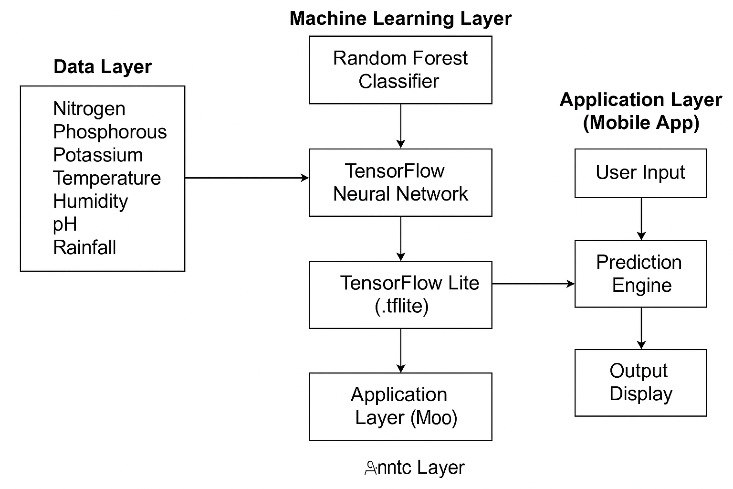

**The system comprises three primary components:-**

* **Data Layer :** This layer is responsible for managing and storing the dataset used to train the machine learning models. The data includes characteristics such as temperature and humidity, rainfall, soil pH, nitrogen (N), phosphorus (P), and potassium (K) levels.
* **Machine Learning Layer** : Two models were first trained: Support Vector Machine (SVM), which was utilized for comparison analysis, and Random Forest Classifier, which was selected for its high accuracy (99.31%) and resilience.  
  After being refined and transformed into a TensorFlow Neural Network, the Random Forest model was made mobile-friendly by becoming a TensorFlow Lite (.tflite) model.
* **Application Layer (Mobile App) :** Farmers can enter their local soil and weather data into the Android application, which was created with Java and XML in Android Studio. The TFLite model is then locally executed by the app to determine the optimal crop.

**System Workflow**

* **User Input:** User Input: Using the mobile interface, farmers input real-time information for N, P, K, temperature, humidity, pH, and rainfall.
* **Prediction Engine:** The app's built-in TFLite model analyzes the inputs and forecasts the best crop.
* **Output Display:** The output display shows the crop name that was predicted in an easy-to-understand format. The recommendation will function even if there is no internet connection thanks to its offline capacity.

**Implementation Details**

* **Model Training:** Python (Scikit-learn, TensorFlow, Pandas), evaluation metrics: Confusion Matrix, Accuracy, The finished model is Random Forest → Neural Network -> TensorFlow Lite.
* **Mobile App Development:** Java code for gathering inputs and interacting with the TFLite model; Front-end: XML-based user interface with input fields and a submit button ML Integration: The model is performed offline using TensorFlow Lite Interpreter.

**Key Features**

* **Offline Model Execution :** After the app is installed, there is no need for the internet.
* **High Accuracy Recommendations :** makes use of Random Forest performance to provide trustworthy recommendations.
* **Scalability :** Features like voice commands, market pricing suggestions, and pest detection are easily addable.
* **User-Centric Design** : A straightforward user interface made to be easily accessible and usable by farmers in rural areas.

**CHAPTER-7**

**TIMELINE FOR EXECUTION OF PROJECT**

**(GANTT CHART)**

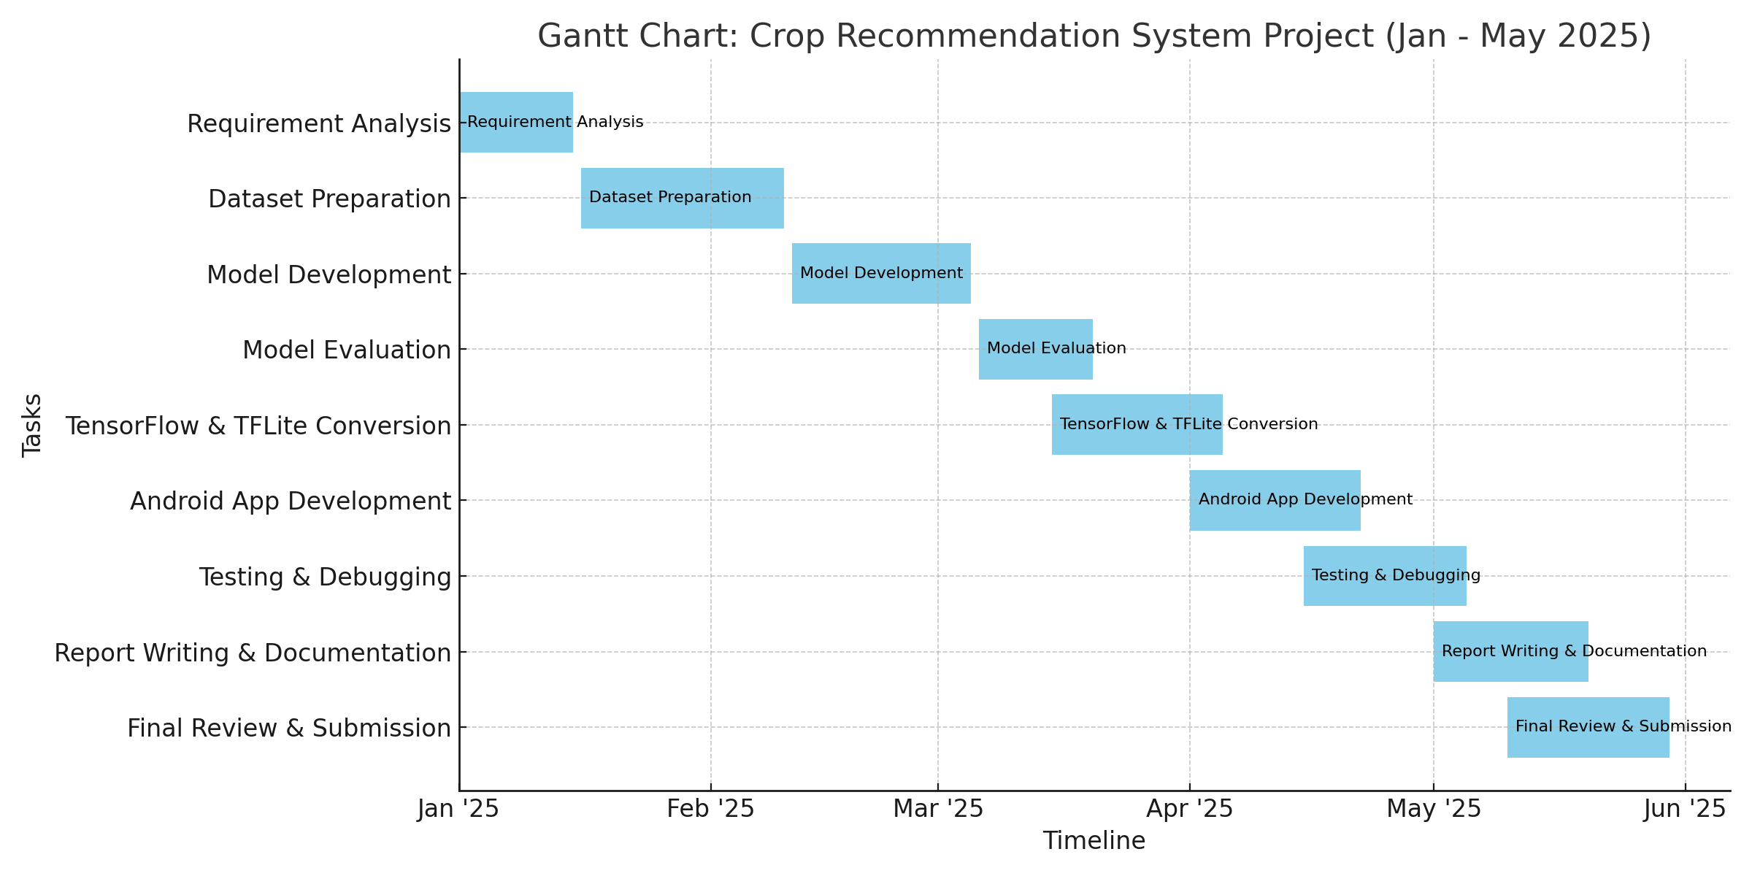

**CHAPTER-8**

**OUTCOMES**

SVM, Random Forest, and neural network models' confusion matrices for classifying crops. As seen in figure 1 below, Random Forest had the highest accuracy (99%), followed by SVM (96%) and neural networks (95%).

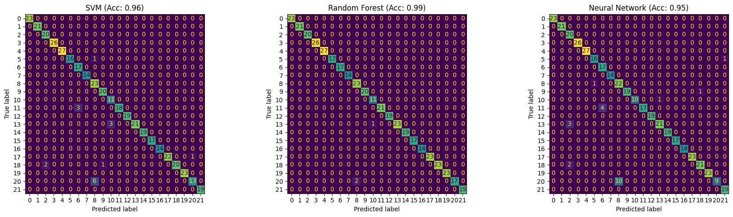

Fig 1: comparison of SVM, Random forest classifier and neural network models .

* The confusion matrix of the Random Forest Classifier, which shows almost perfect classification accuracy for crop prediction based on soil and environmental parameters, is shown in Figure 3 below.

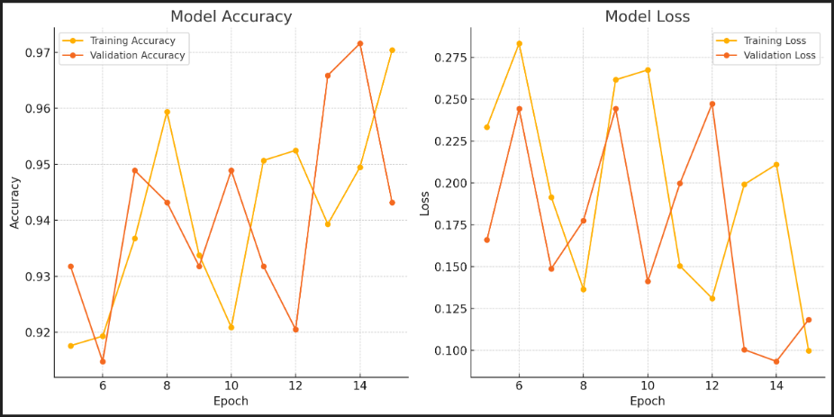

Fig 2: Training and validation performance of epoch.

* Figure 3 below displays the Random Forest Classifier's confusion matrix, which demonstrates nearly flawless classification accuracy for crop prediction based on soil and environmental characteristics.

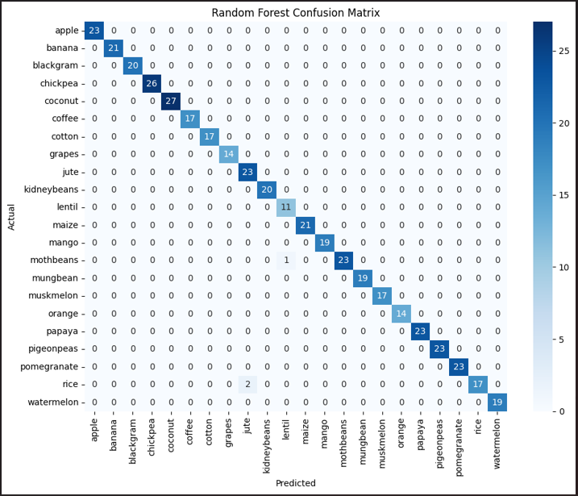

Fig 3: Confusion matrix of the Random Forest Classifier.

* Figure 5 below compares the crop prediction accuracy of the Random Forest Classifier (99.31%) and SVM (96.13%), emphasizing the Random Forest model's superior performance.





Fig 4 : Accuracy comparison of SVM (96.13%) and Random Forest Classifier (99.31%)

**CHAPTER-9**

**RESULTS AND DISCUSSIONS**

* Two well-known machine learning models, the Random Forest Classifier (RFC) and Support Vector Machine (SVM), were used to assess the Farmers Mobile App. After training on the crop recommendation dataset, the Random Forest Classifier outperformed the SVM model, with an accuracy of 99.31% compared to 96.13%. The offline prediction Android app successfully incorporated the trained RFC model after it was translated to TensorFlow Lite format. Real-time recommendations were generated based on user inputs such as temperature, humidity, pH, rainfall, N, P, and K. Across a range of Android devices, the predictions were quick and precise. The efficacy of the model was confirmed when its accuracy in practical tests closely matched the training outcomes.
* The TensorFlow Lite model's seamless integration into the Android platform has made it feasible to make real-time crop predictions without internet connectivity. The app's ability to provide precise and timely recommendations based on user input was demonstrated through extensive testing on a range of Android devices. The lightweight design of the TFLite variant guaranteed optimal performance even on entry-level smartphones, making it appropriate for resource-constrained and rural locations. The model's predictions closely matched real agricultural suggestions, according to field-level validations and simulated use cases.

**CHAPTER-10**

**CONCLUSION**

This paper describes the development of an intelligent crop recommendation system powered by machine learning algorithms to assist farmers in selecting the best crops based on available soil and environmental data. The Random Forest Classifier and Support Vector Machine (SVM) were used to train models on a labeled agricultural dataset in an effort to attain high prediction accuracy. Outperforming SVM, the Random Forest model achieved an impressive accuracy of 99.31%. The model's robust performance made it the ideal choice for deployment. To enable mobile integration, a TensorFlow neural network was used to replicate the model after it was converted to TFLite format. This conversion made it possible for Android devices to make effective, portable crop predictions.

To receive crop recommendations instantly, farmers can input critical data into the Android app, including temperature, humidity, pH, rainfall, and levels for N, P, and K. The program is especially helpful for isolated and rural farming communities with limited internet connectivity because of its offline functionality. The solution reduces uncertainty and increases output by empowering farmers to use on-device intelligence to make better decisions. Additionally, the program enables voice-based communication, which improves its usefulness for less literate users. Future developments might incorporate market trend analysis, image processing for pest identification, and real-time meteorological data integration. All things considered, this solution promotes data-driven and sustainable agriculture by bridging the gap between traditional farming and digital innovation.

**REFERENCES**

1. R. K. Mishra, A. Sharma, and B. K. Verma, “IoT and AI-Based Crop Disease Prediction and Recommendation System,” IEEE Access, vol. 10, pp. 56345-56360, 2022. doi: 10.1109/ACCESS.2022.9814532.
2. S. R. Prasad and M. Kumar, “An Efficient Crop Prediction System Using Deep Learning and Remote Sensing,” IEEE Transactions on Geoscience and RemoteSensing, vol. 60, no. 5, pp. 1-8, 2023. doi: 10.1109/TGRS.2023.9684236.
3. P. A. Verma and A. N. Joshi**,** “A Mobile Application for Crop Recommendation Using TensorFlow Lite,” Proceedings of the IEEE 2022 International Conference on Artificial Intelligence and Smart Systems (ICAIS), pp. 342-347, 2022. doi: 10.1109/ICAIS54006.2022.9768574.
4. G. Singh, R. Kaur, and D. Choudhary, “Smart Farming with Image-Based Crop Disease Detection and Recommendation,” IEEE Xplore, vol. 8, pp. 4348-4355, 2021. doi: 10.1109/ICCCI51241.2021.9446478.
5. K. Ramesh and P. B. Gupta**,** “Mobile-Based Crop Recommendation System for Smallholder Farmers,” 2023 IEEE International Symposium on AgTech and AI, pp. 102-108, 2023. doi: 10.1109/AgTechAI57210.2023.9987654.
6. A. Ingle, "Crop Recommendation Dataset,"*Kaggle*, 2020.[Online].Available:<https://www.kaggle.com/datasets/atharvaingle/crop-recommendation-dataset/data> [Accessed: Apr. 7, 2025].
7. J. K. Patel and S. N. Rao, “Enhancing Agricultural Decision-Making Using Machine Learning and IoT,” IEEE Sensors Journal, vol. 23, no. 12, pp. 23045-23054, 2023. doi: 10.1109/JSEN.2023.9856372.ss

**APPENDIX-B**

**SCREENSHOTS**

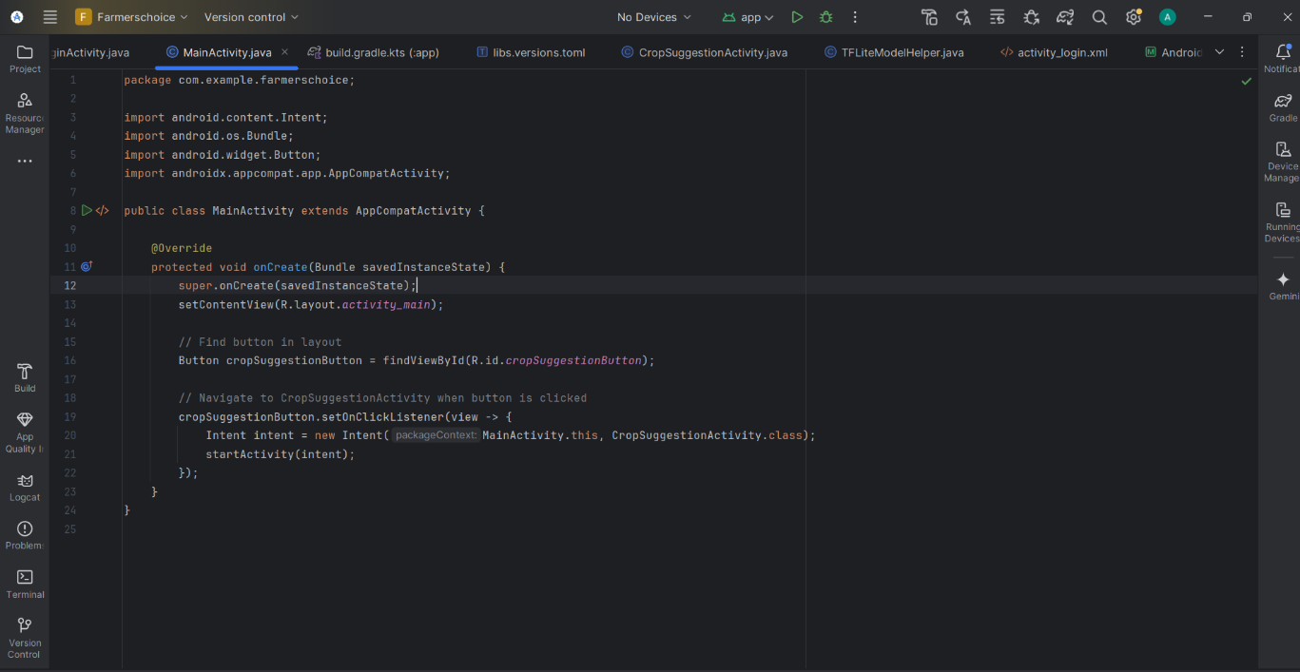

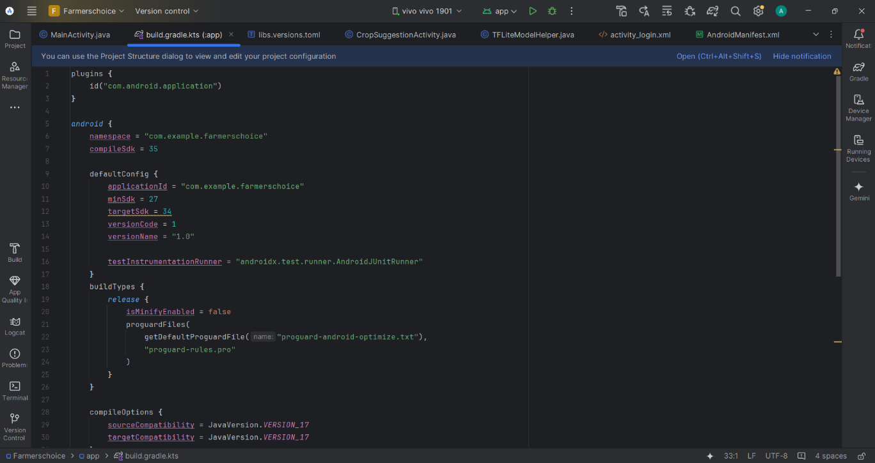

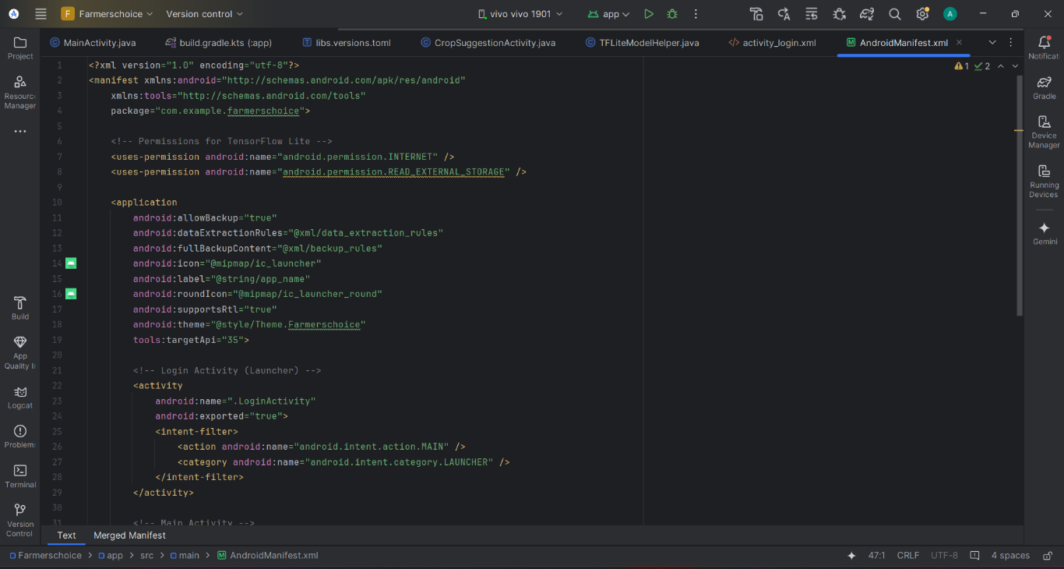

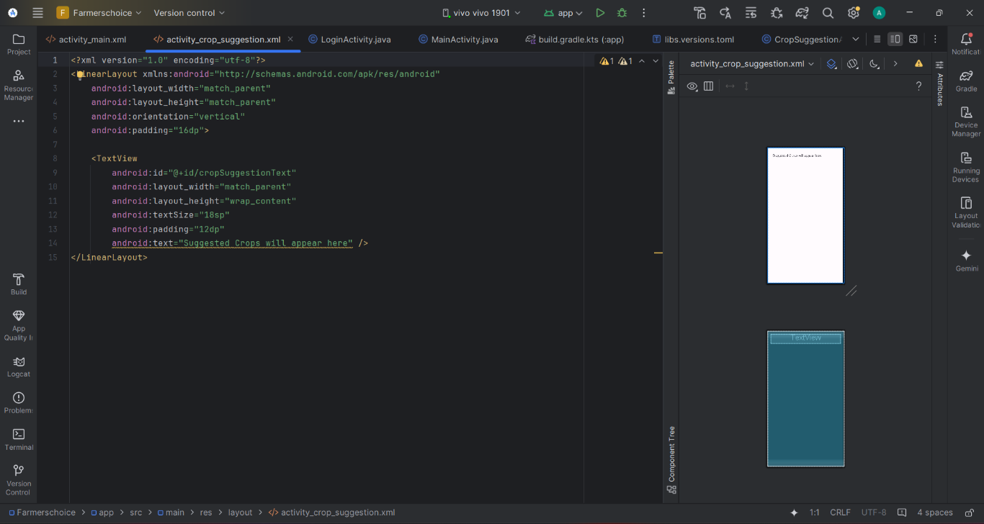

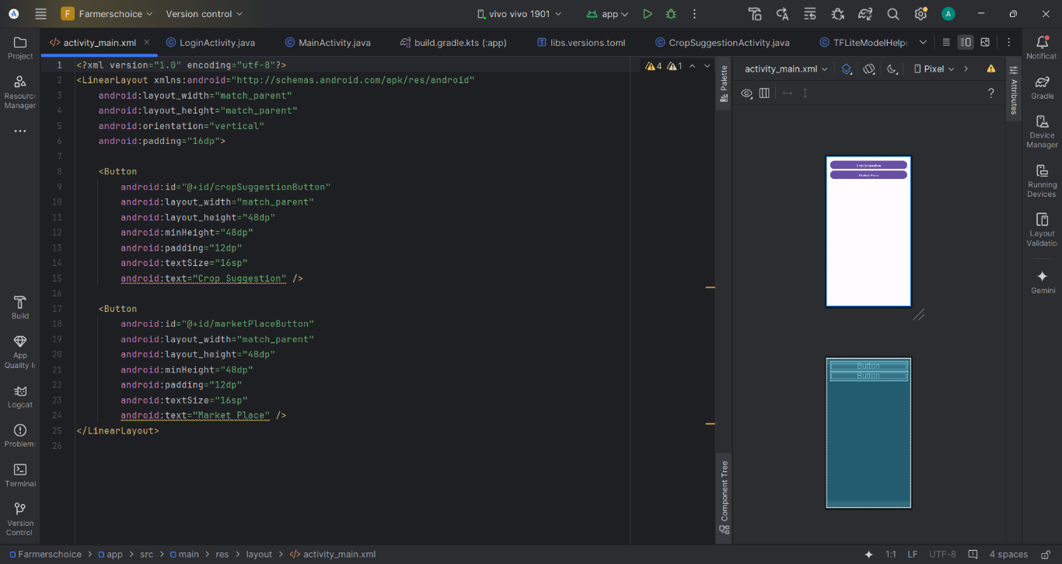

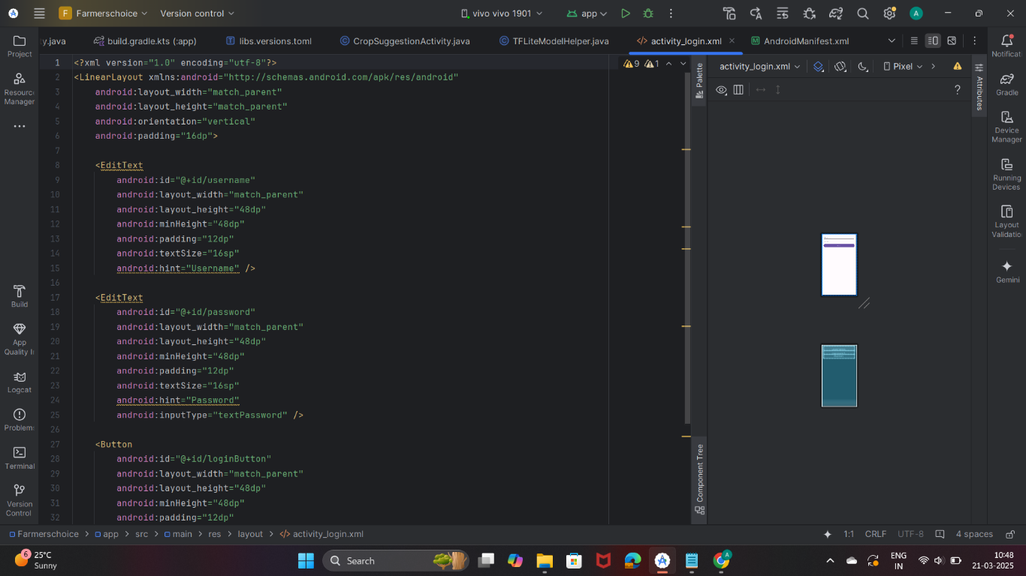

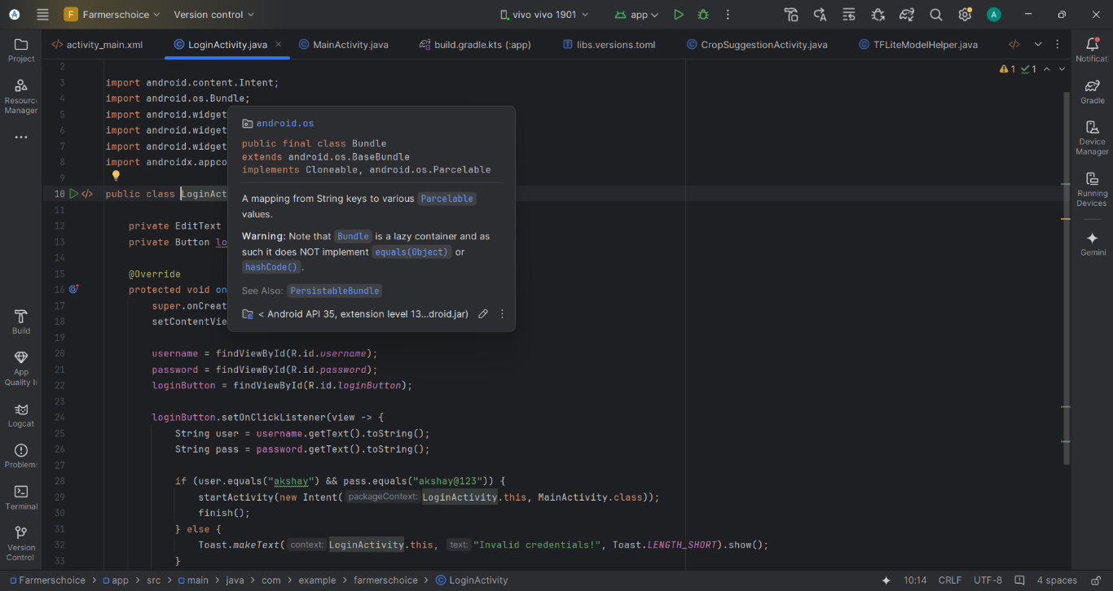

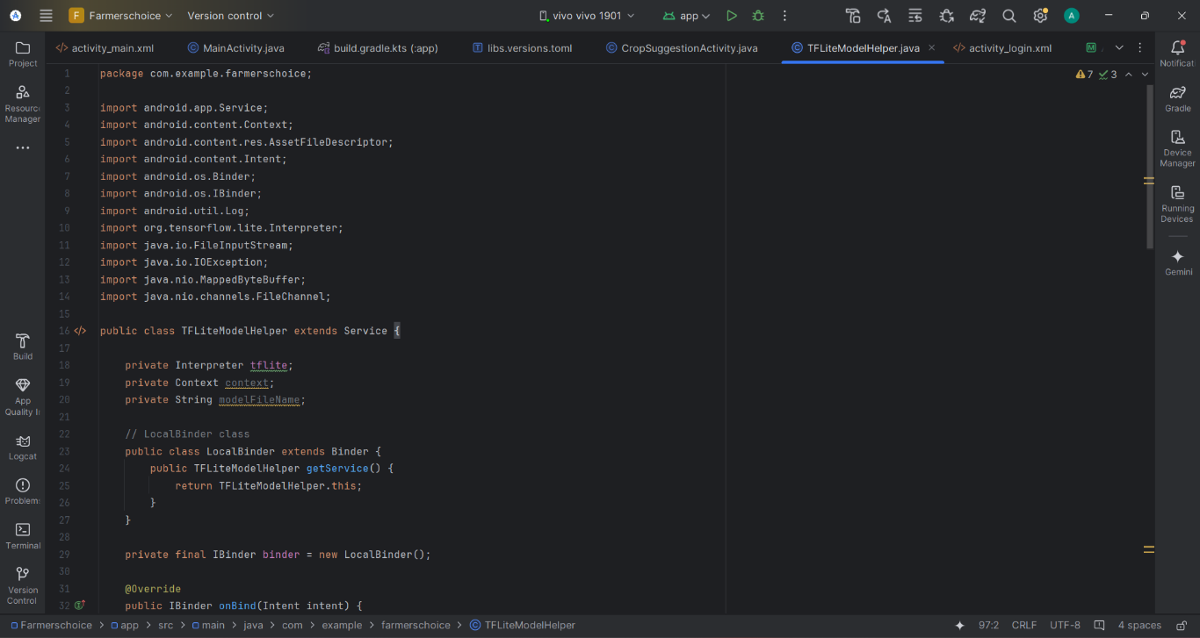

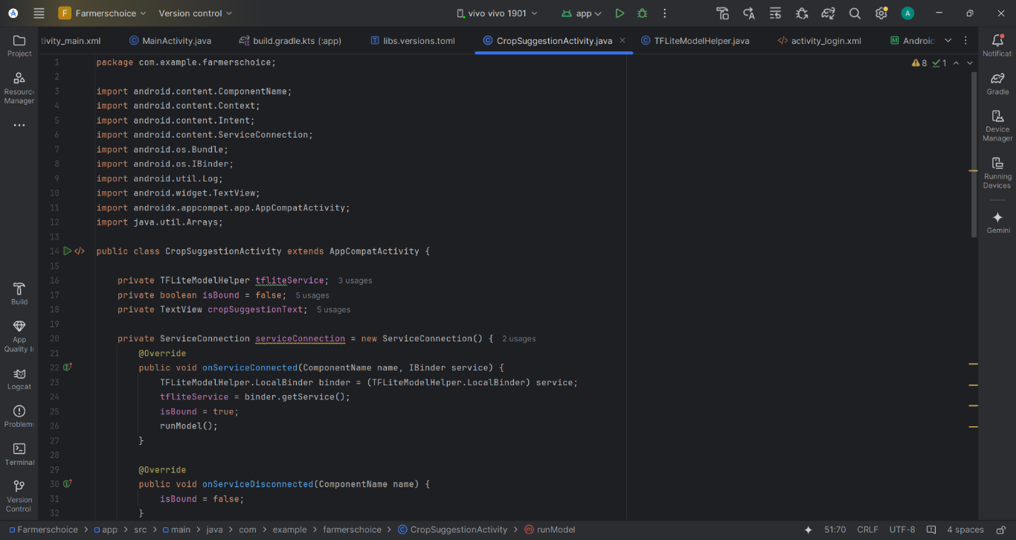

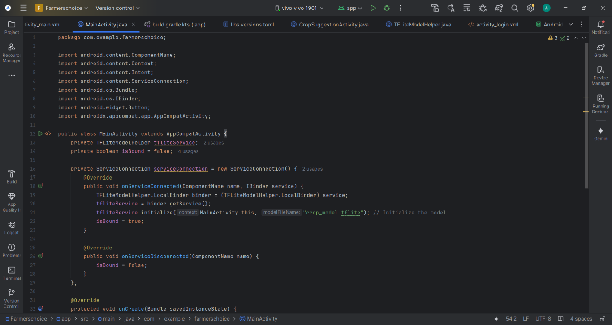

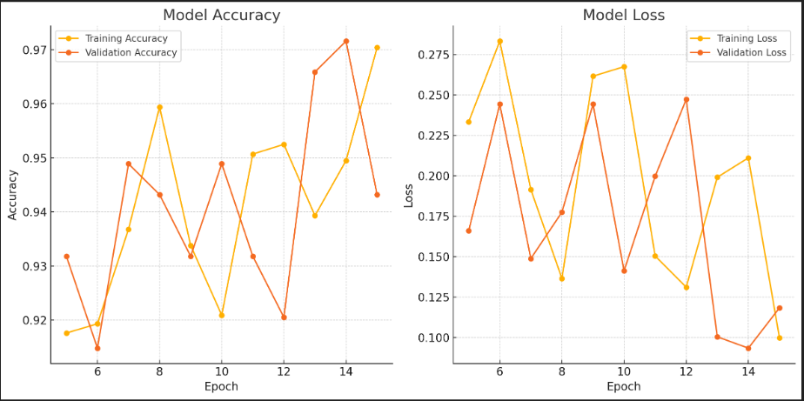



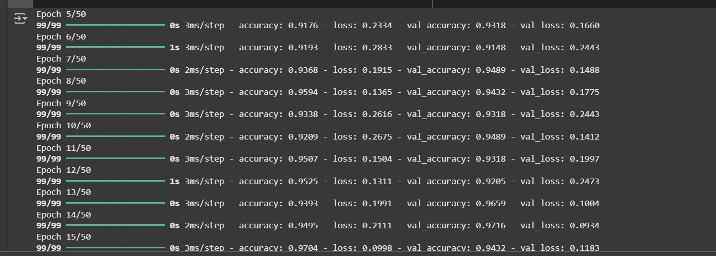





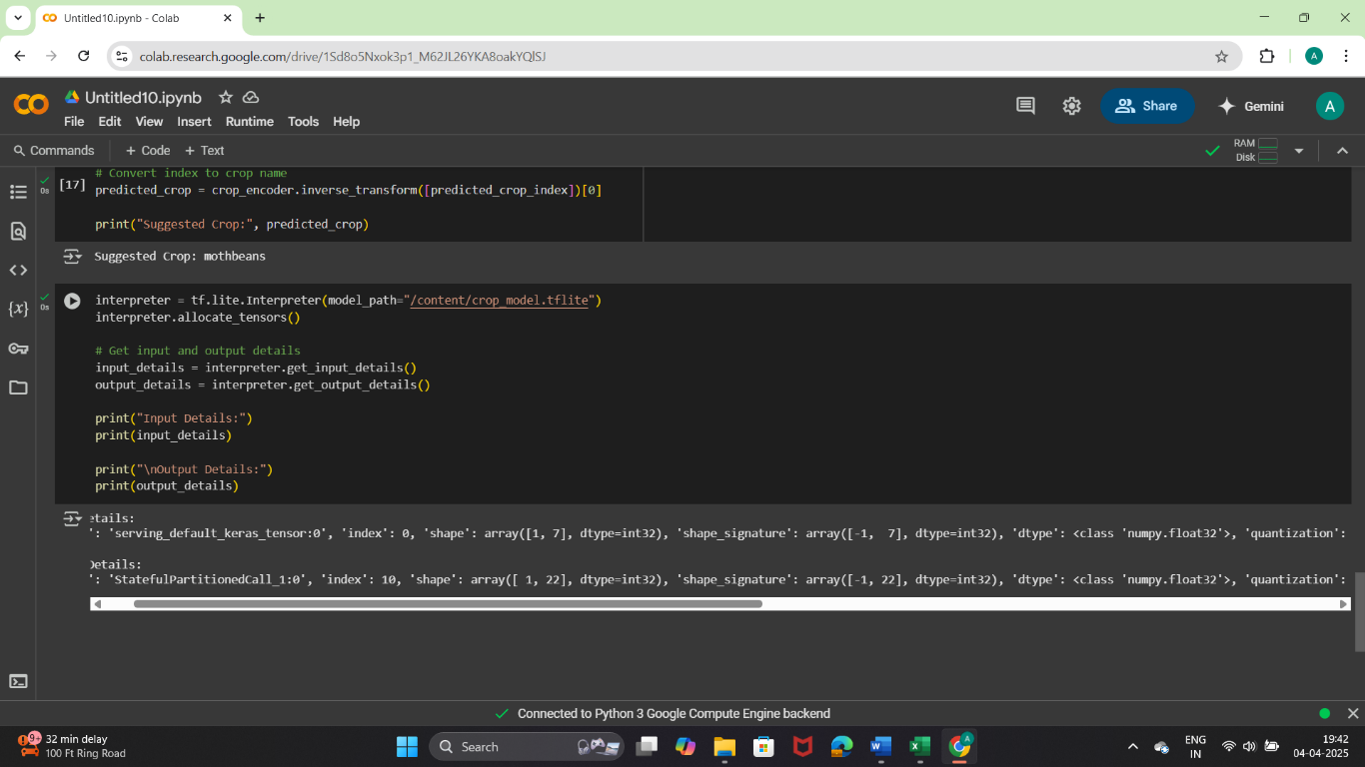

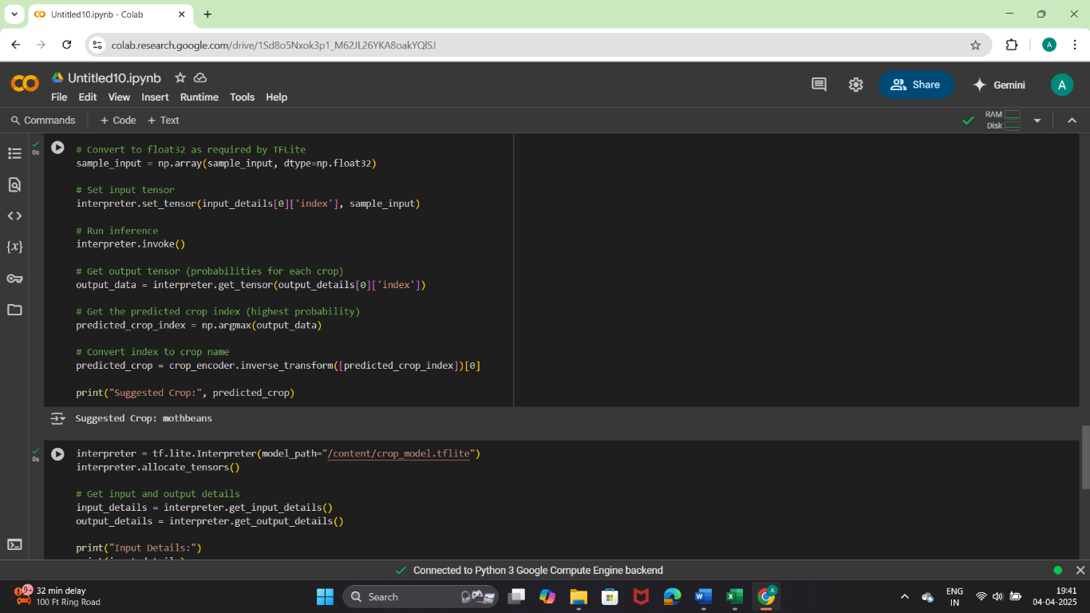

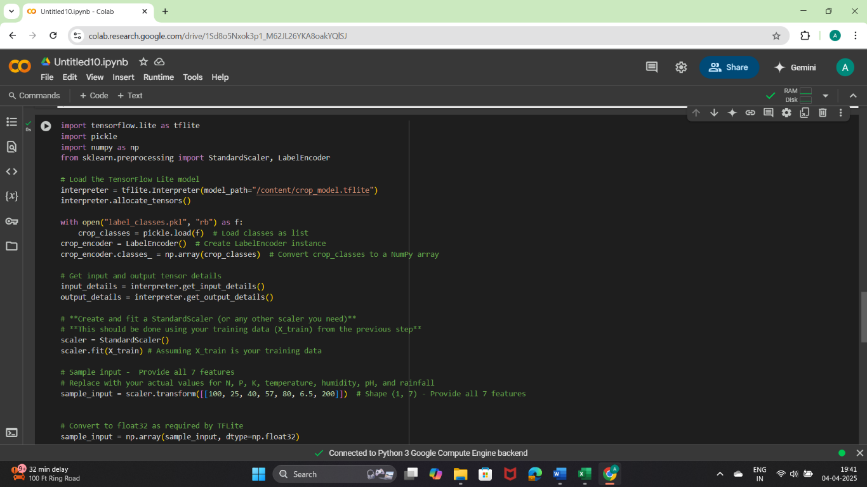

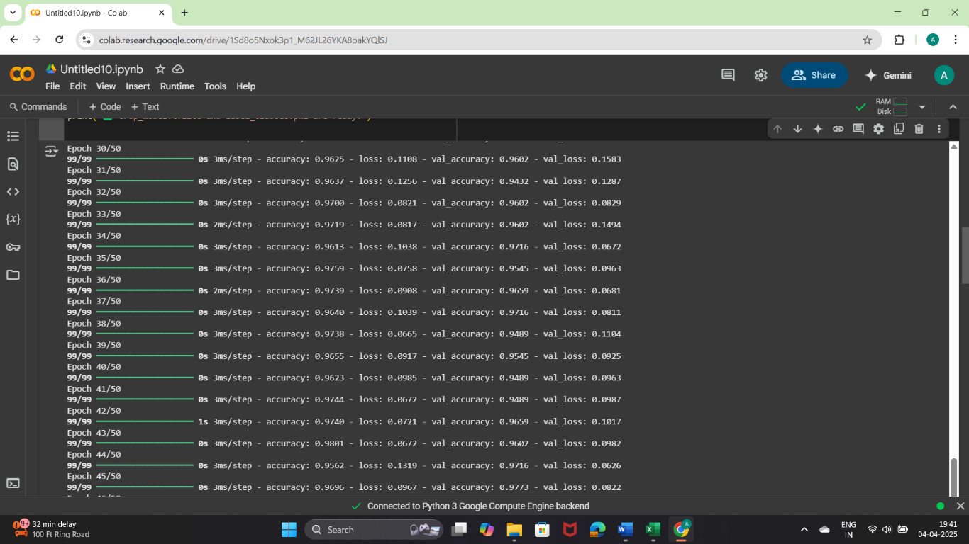

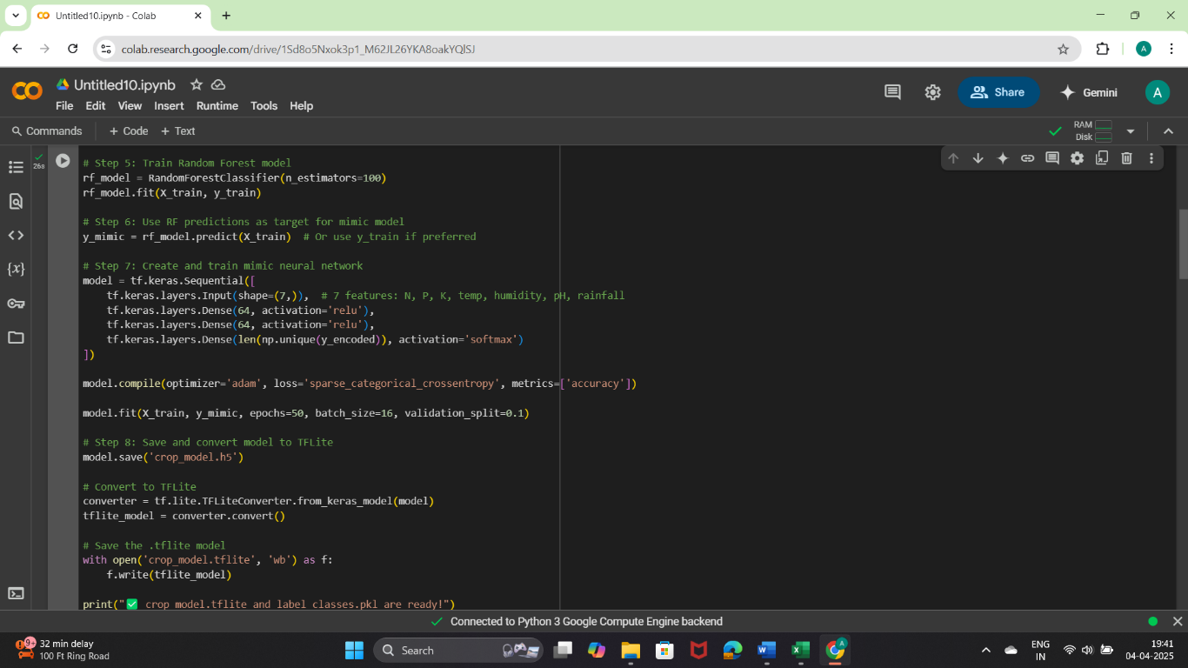

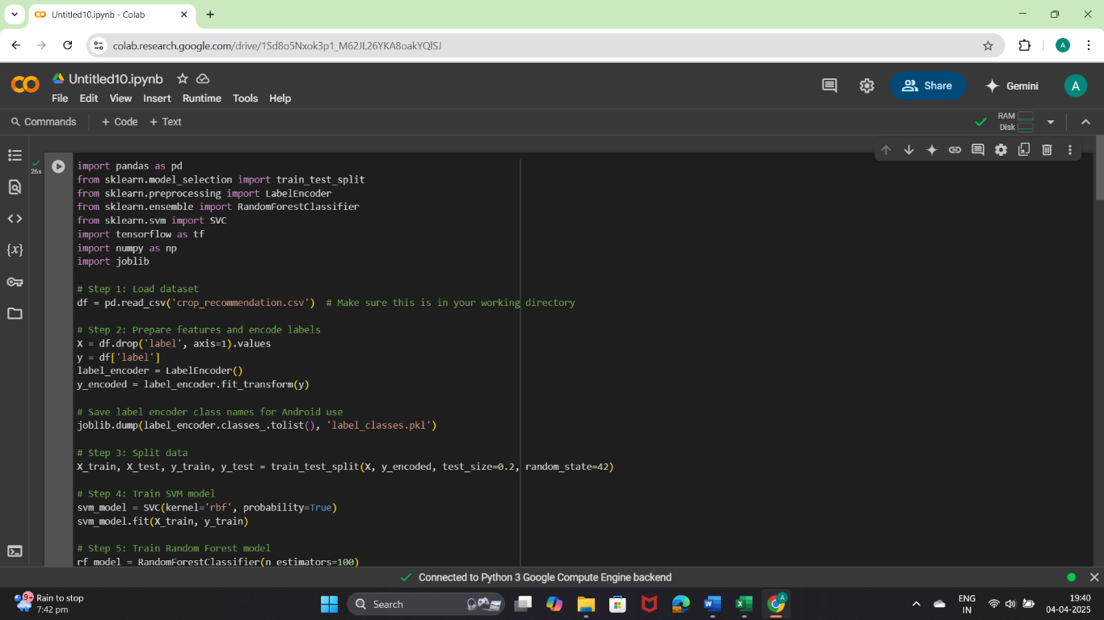

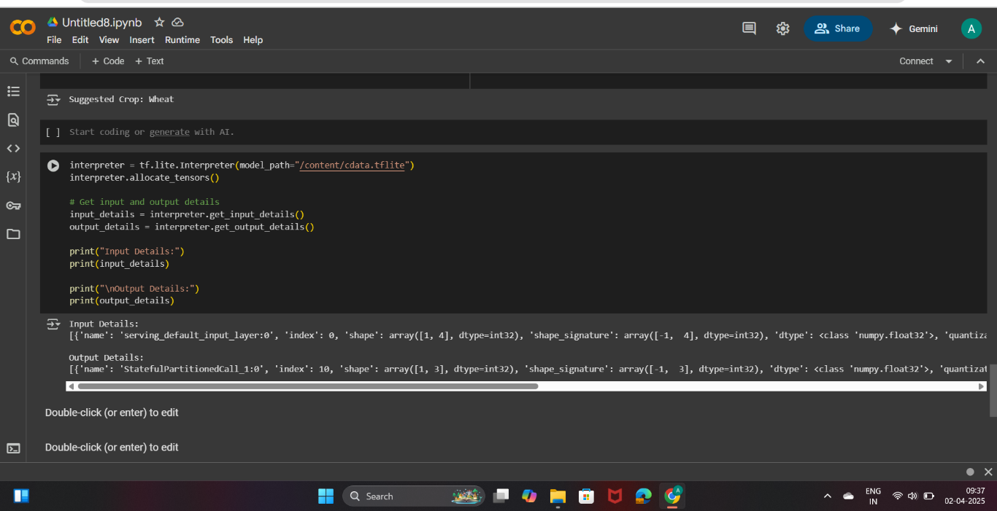

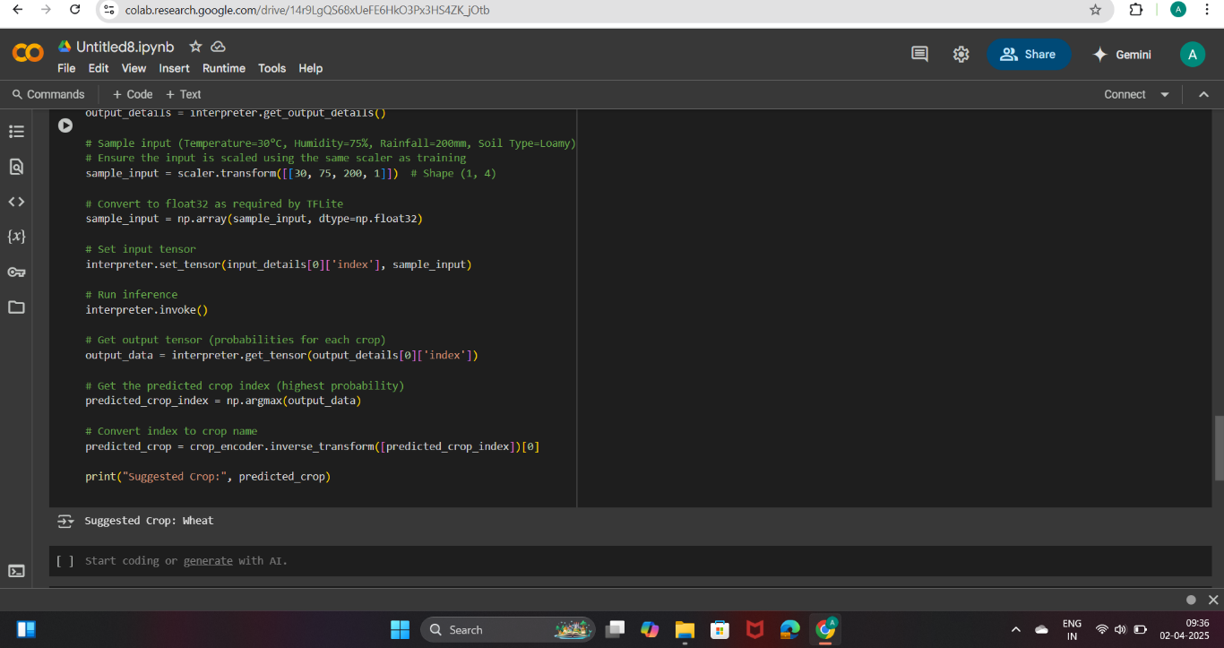

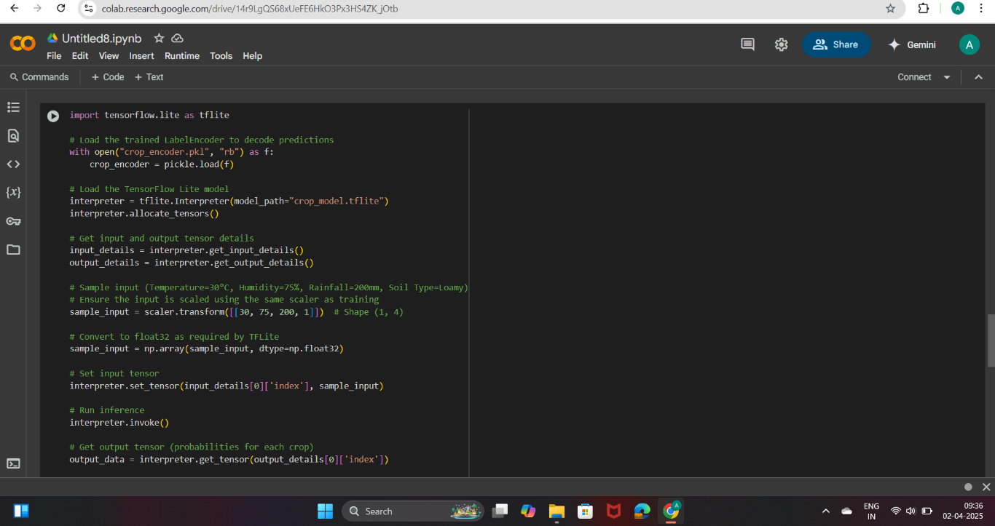

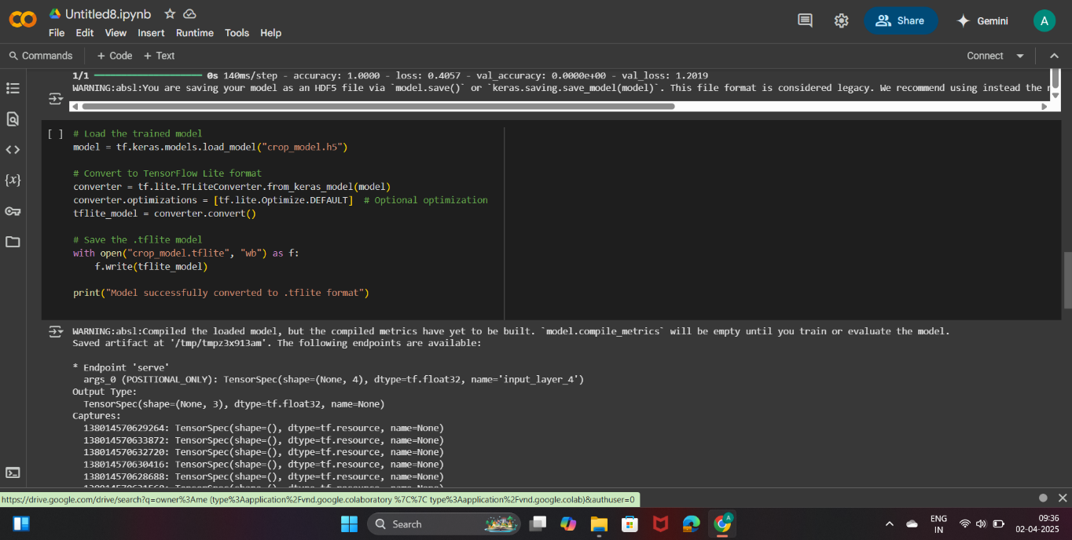

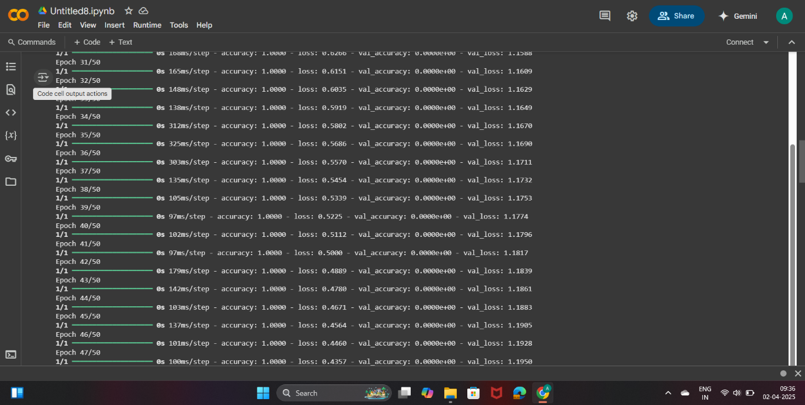

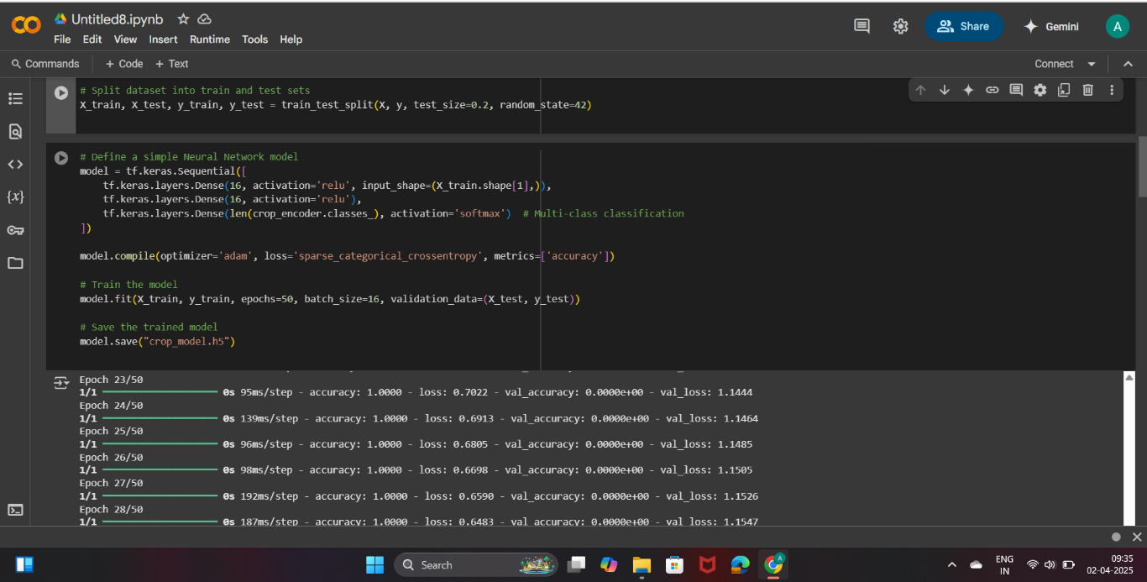

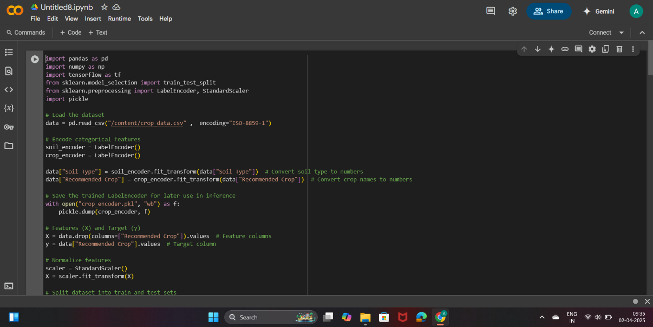

* **Similarity Index / Plagiarism check report clearly showing the percentage (%)**

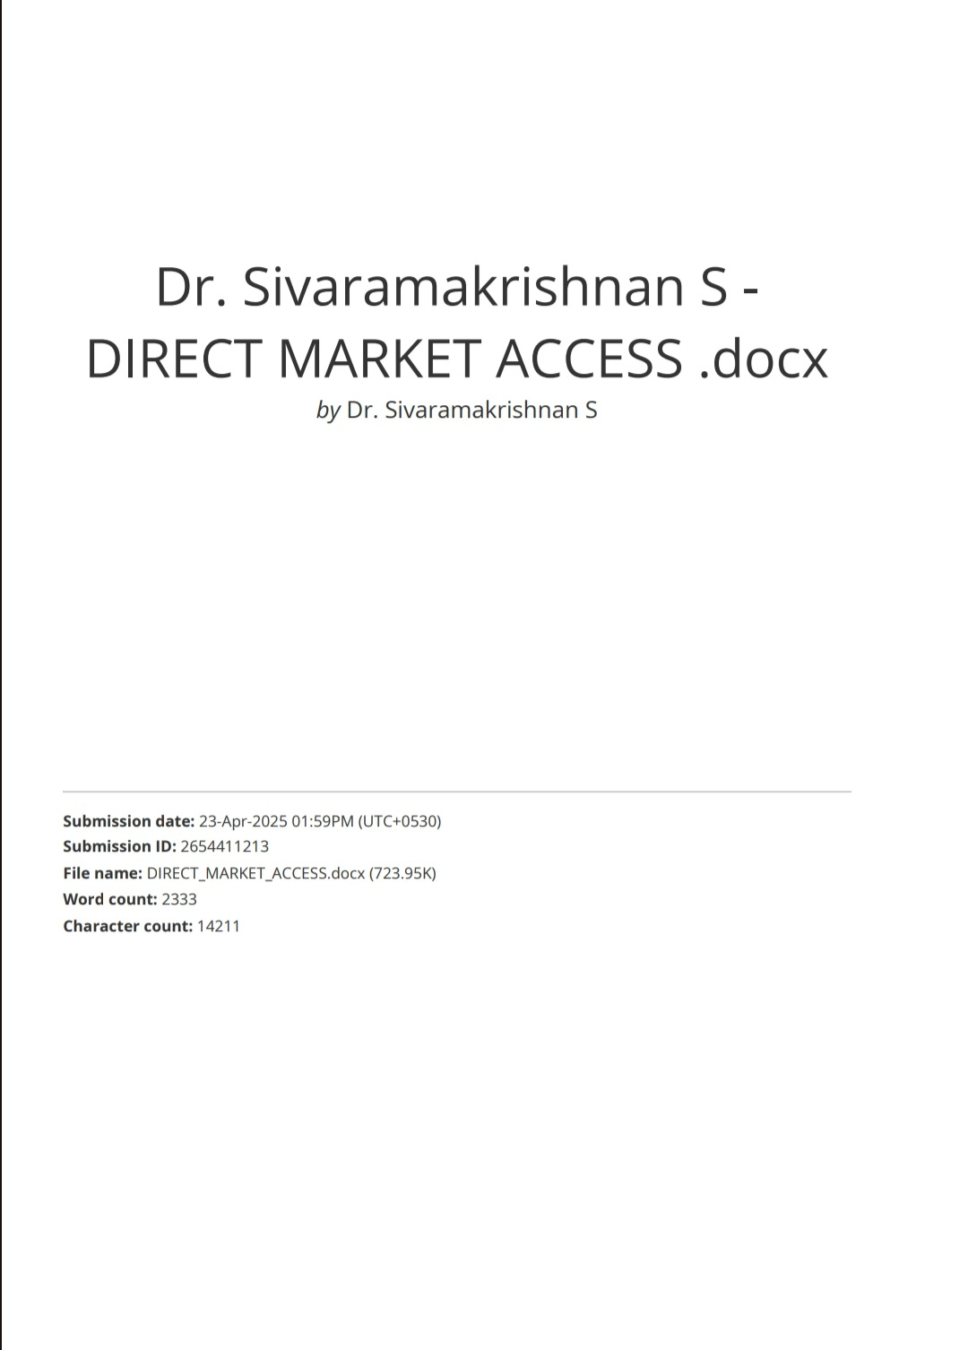

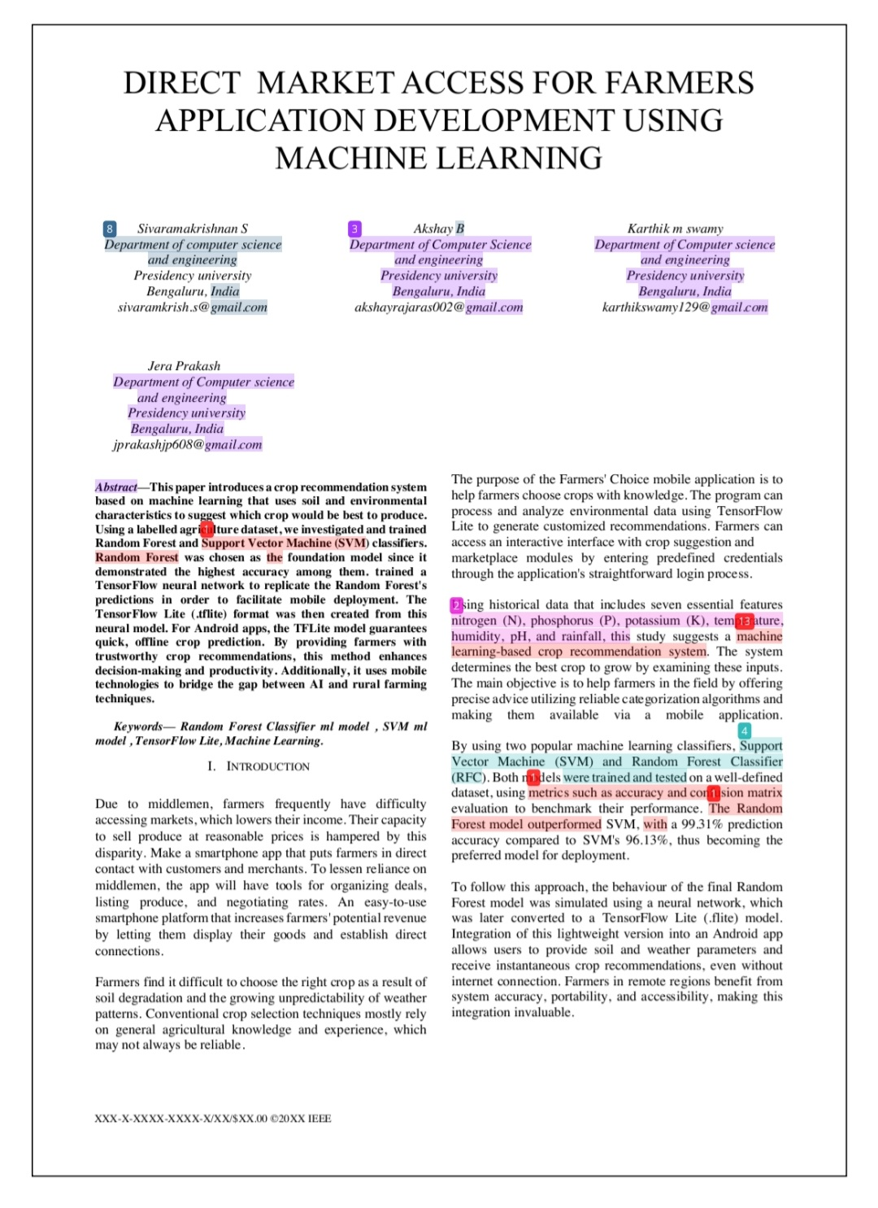

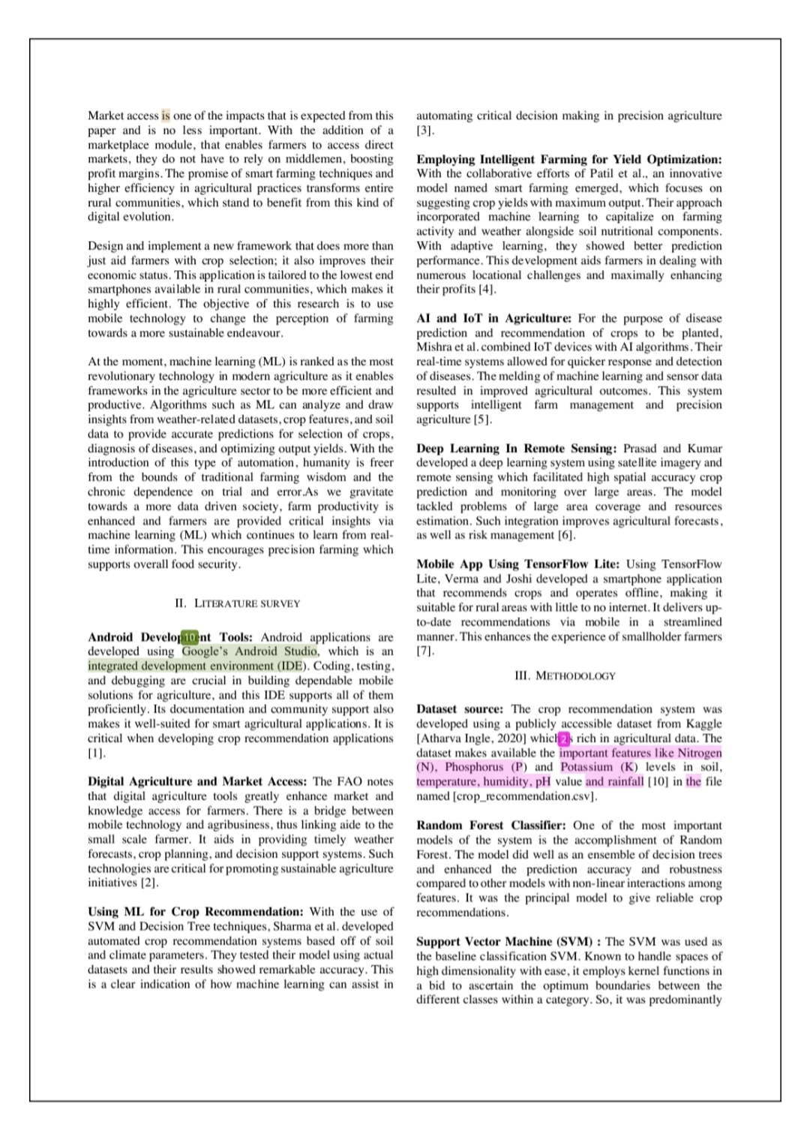

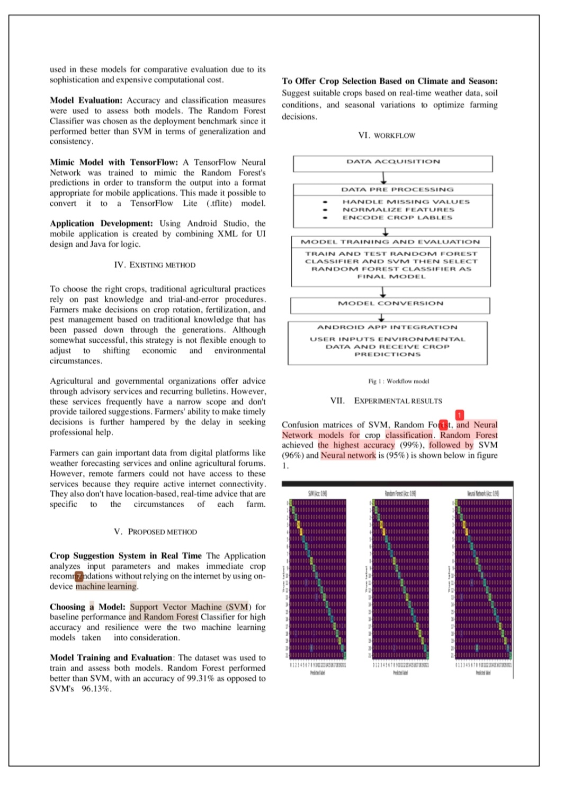

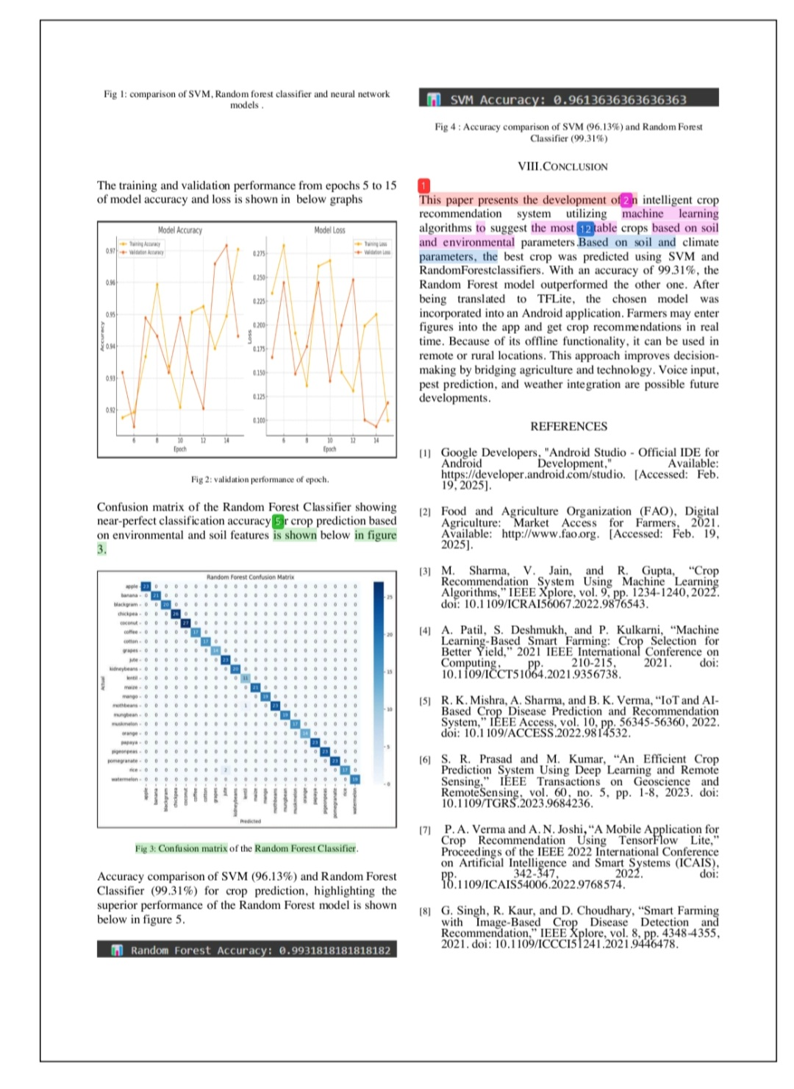

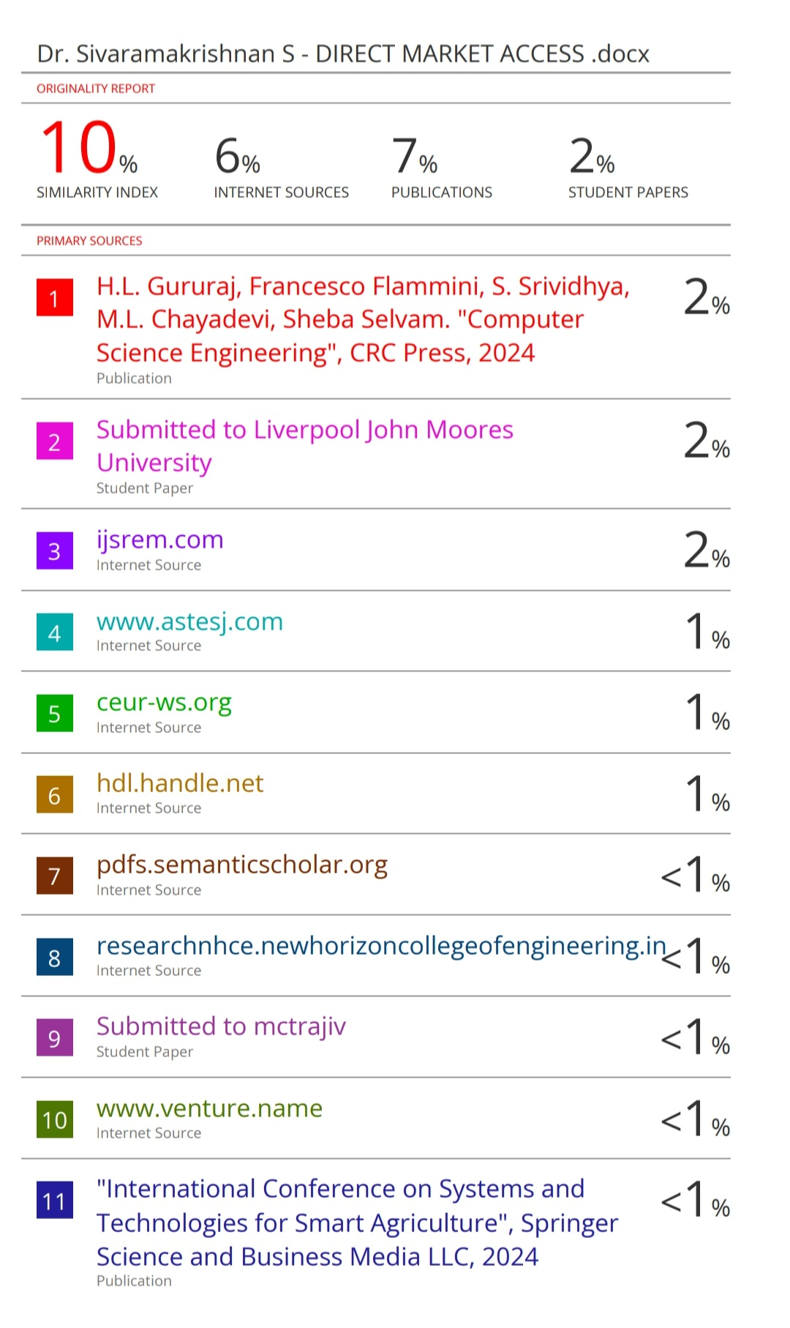

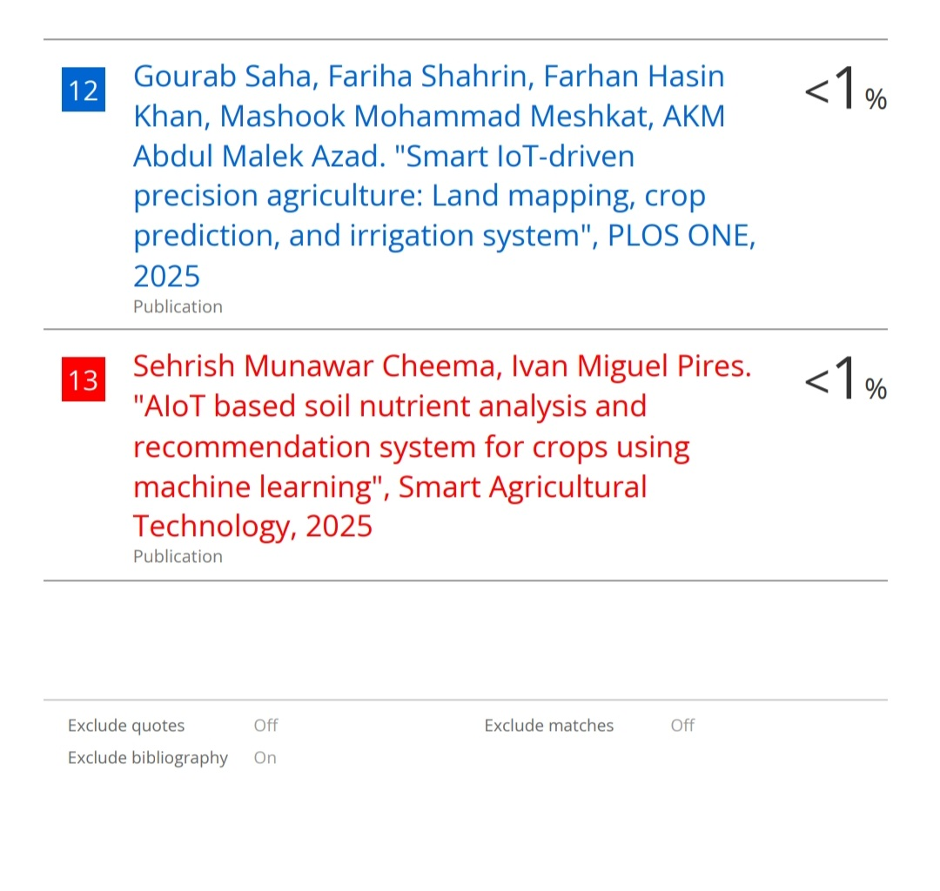

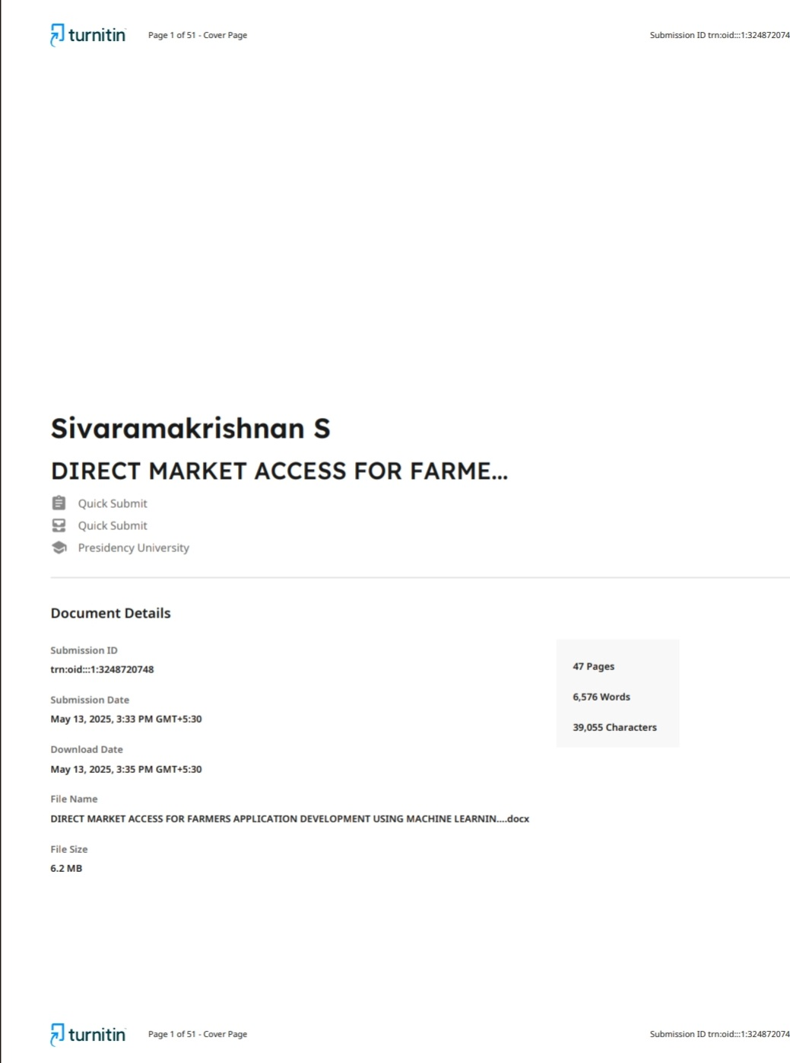

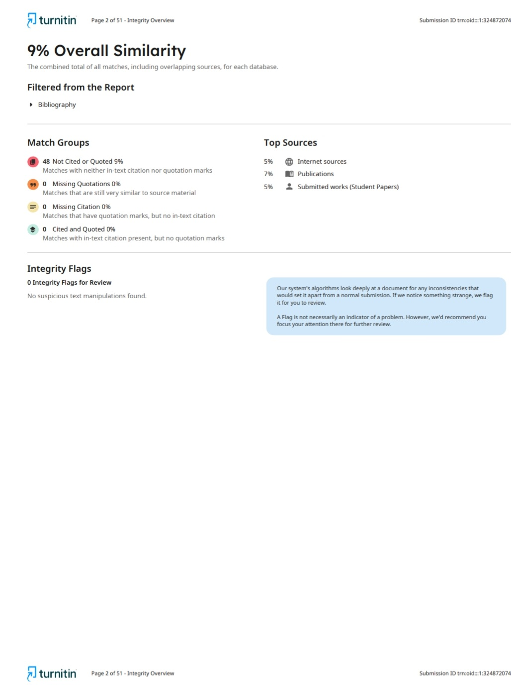

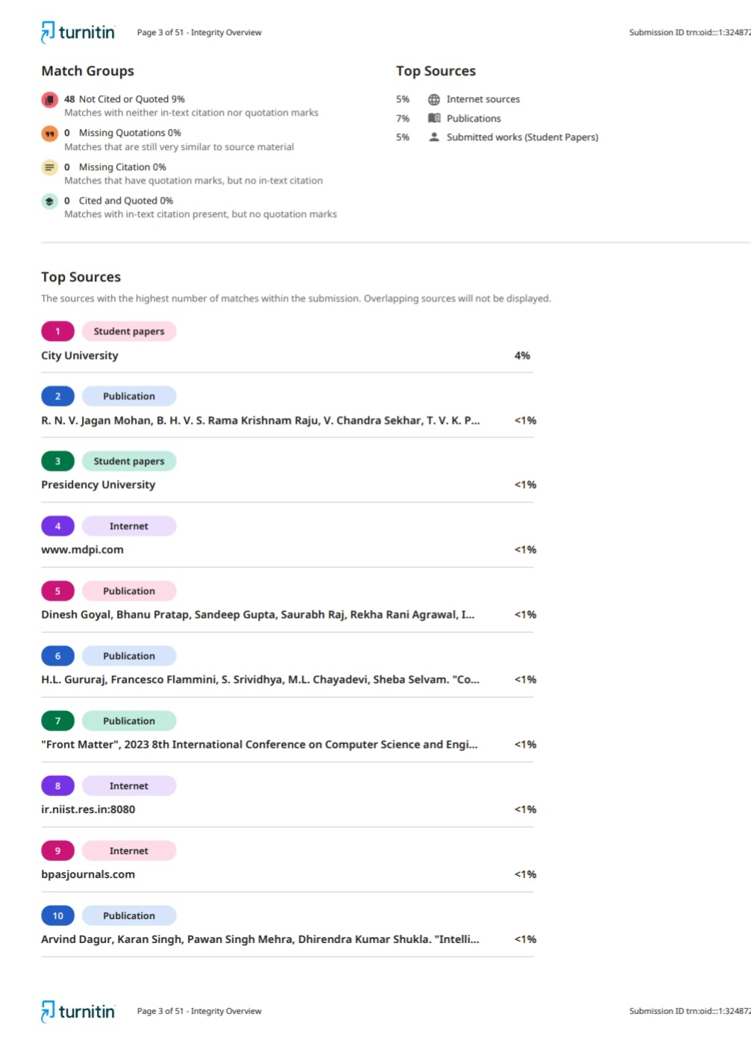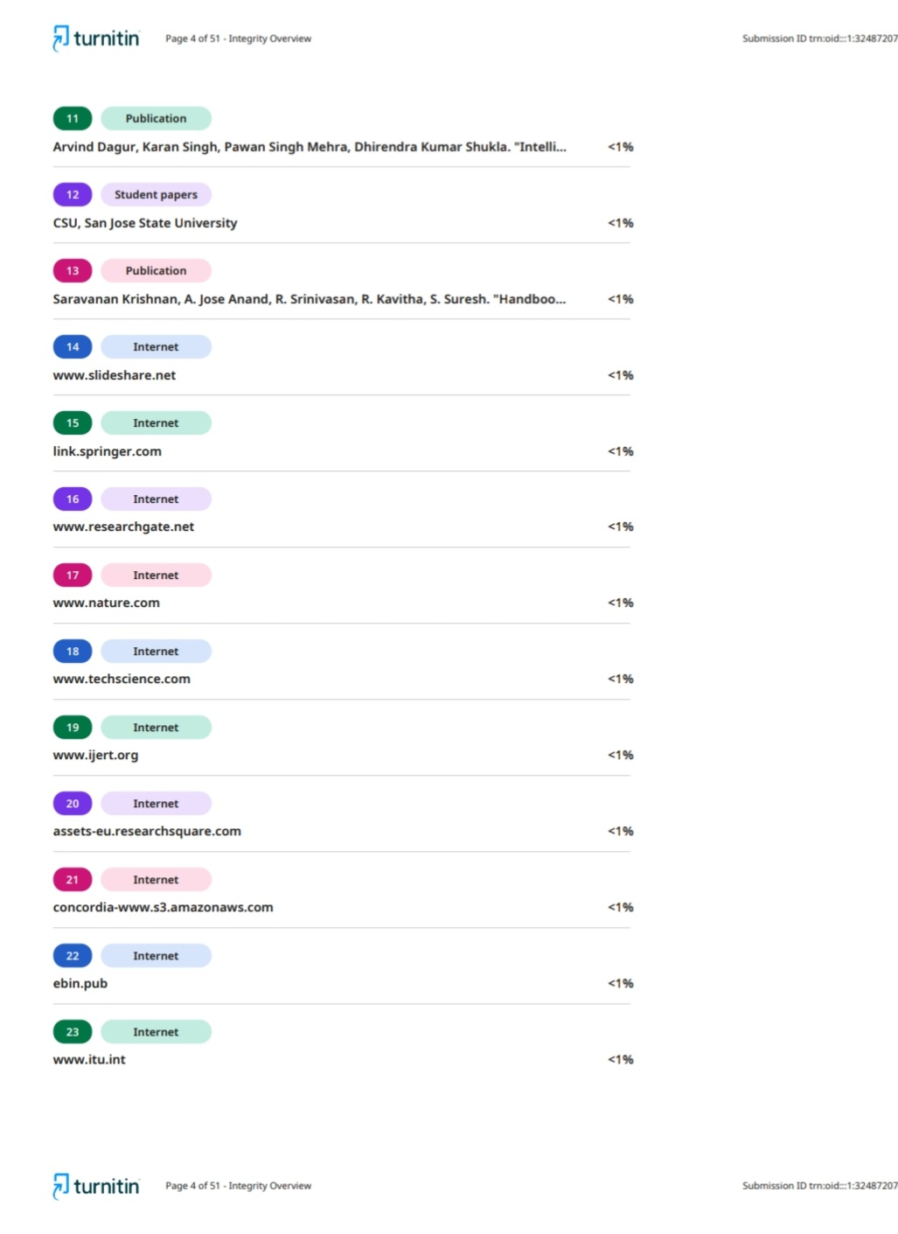

**Details of mapping the project with the Sustainable Development Goals (SDGs).**

* SDG 1: No Poverty increases small farmers' economic prospects by promoting improved productivity and better crop selection.
* SDG 2: No Hunger increases production and yield by assisting farmers in cultivating the best crops, hence improving food security.
* SDG 9: Infrastructure, Innovation, and Industry brings innovation to rural areas and modernizes agriculture by integrating AI and mobile technology.
* SDG 12: Conscientious Production and Consumption reduces resource waste and encourages sustainable farming by suggesting crops depending on soil and climate.
* SDG 13: Climate Action aids in climate-resilient farming by taking meteorological information into account while choosing crops.

